Castile United Church of Christ
P.O. Box 512 Castile, NY 14427
Church Phone: 585-493-2840
Church E-Mail: Castile_UCC@yahoo.com
www.castileucc.com
Pastor: Tammy Lathan
Tammy’s Cell Phone: 585-969-0695
United Flyer Editor: Marlene Loomis


JULY 2023 “United Flyer”



“For Many are Called, But Few Are Chosen”
- Matthew 5

You are cordially invited to join us for the

Service of Installation
For Pastor Tammy Lathan, as the Settled Pastor

OF the Castile United Church of Christ
Sunday, July 23, 2023 at 10:00 AM.

A reception will follow in the Embling Dining Hall


Talks With Pastor Tammy

Rich Boss Picks Penny Up And

Explains Its True Value -
Several years ago, a friend of mine and her husband were invited to spend the weekend at the husband's employer's home. My friend, Arlene, was nervous about the weekend. The boss was very wealthy, with a fine home on the waterway, and cars costing more than her house.
As the three of them were about to enter an exclusive restaurant that evening, the boss was walking slightly ahead of Arlene and her husband.
He stopped suddenly, looking down on the pavement for a long, silent moment.
Arlene wondered if she was supposed to pass him. There was nothing on the ground except a single darkened penny that someone had dropped, and a few cigarette butts. Still silent, the man reached down and picked up the penny.
He held it up and smiled, then put it in his pocket as if he had found a great treasure. How absurd! What need did this man have for a single penny? Why would he even take the time to stop and pick it up?
Throughout dinner, the entire scene nagged at her. Finally, she could stand it no longer. She casually mentioned that her daughter once had a coin collection, and asked if the penny he had found had been of some value.
A smile crept across the man's face as he reached into his pocket for the penny and held it out for her to see. She had seen many pennies before! What was the point of this? "Look at it," he said. "Read what it says."
She read the words, "United States of America?"
"No, not that; read further."
"One cent?"
"No, keep reading."
"In God We Trust?"
"Yes!" "And?"
"And if I trust in God, the name of God is holy, even on a coin. Whenever I find a coin, I see that inscription. It is written on every single United States coin, but we never seem to notice it! God drops a message right in front of me telling me to trust Him? Who am I to pass it by?
When I see a coin, I pray, I stop to see if my trust IS in God at that moment. I pick the coin up as a response to God; that I do trust in Him. For a short time, at least, I cherish it as if it were gold. I think it is God’s way of starting a conversation with me. Lucky for me, God is patient and pennies are plentiful!"
When I was out shopping today, I found a penny on the sidewalk. I stopped and picked it up, and realized that I had been worrying and fretting in my mind about things I cannot change. I read the words, "In God We Trust," and had to laugh. Yes, God, I get the message.
God's signs are all around us. Sometimes, we just overlook them because of their simplicity. Keep your eyes peeled, but more importantly, keep your trust in Him!
Reprinted from Godvines.com


TEMPORARY OFFICE HOURS

Until further notice, the church office hours will be as follows, while Administrative Coordinator, Marlene Loomis is on leave:
Tues. 8:00 AM - 2:00 PM
Wed. 8:00 AM - 2:00 PM
Thurs. 8:00 AM - 2:00 PM
(Other times by appointment.)
Call Pastor Tammy at 585-969-0695
to make an appointment.

Facebook Live
Most of our worship services can be viewed on Castile UCC Facebook Live or you can view it anytime at your leisure for up to 30 days.
Newsletter Deadline
All newsletter articles for the “United Flyer” are due by the 15th of each month and are at the discretion of the church office. We welcome your submissions.

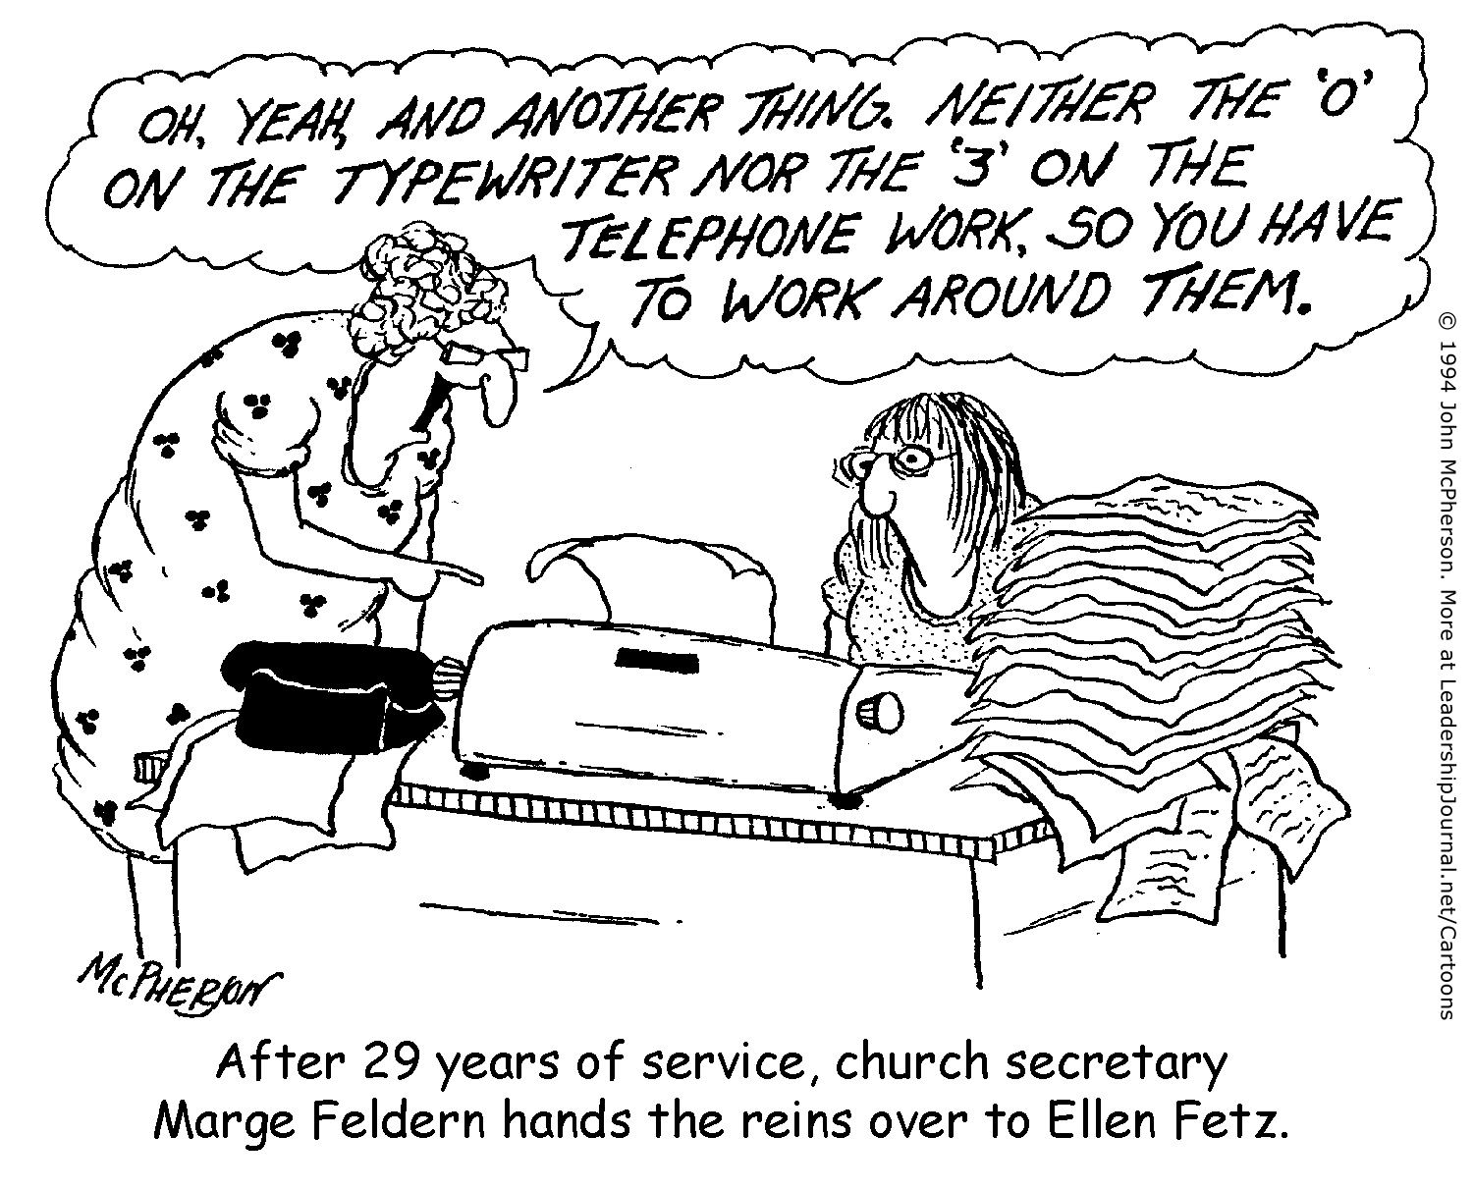

Church Directory
Pastor: Tammy Lathan
Pastor Tammy’s Office Hours:
Tuesday & Thursdays: 8:00 AM - 2:00 PM
Wednesdays – By Appointment
Pastor Tammy’s Cell: (585) 969-0695
Church Phone: (585) 493-2840
Church E-mail: Castile_UCC@yahoo.com
Website: www.castileucc.com

Administrative Coord.: Marlene Loomis - 493-2968
Church Moderator: Dennis Miller - 493-2743
Bd. of Elder Chair: Bonnie Miller - 237-3958
Bd. of Trustees Chair: Scott Chamberlain -752-3454
Custodian: Brooke VanEpps -
Director of Music: Barb Meyer - 322-7396
Supt. of Build/Grounds: Greg VanSlyke - 493-5874

Church Council Meeting
The next Church Council meeting scheduled for Sunday, July 16, 2023 at 11:00 AM.

Please have your reports ready to be copied.

Altar Flowers
July 2- Bonnie Miller
9- Sandy Sickles
16- Barbara Meyer
(In memory of Bob Knipe & Jean Hedges)
23- Cheryl Fagan
(In memory of Barbara Fagan & Louella Howden)
30- Amie Feroleto

Brunch: NO brunches over the Summer.

Castile UCC Food Pantry
The Food Pantry is open to residence in the Town of Castile and may be visited monthly. Contact the church office at 493-2840 to set up an appointment.

Kindness…
“What wisdom can you find that is greater than kindness?”
Jean-Jacques Rousseau

Thank You’s
To Suanne Redden & Christine Broughton for doing the Food Pantry while Sally Bliss is recovering.

To our Decorating Committee for the beautiful altar decorations the past few weeks.

Board of Trustees News

Chicken BBQ - $2,211.31!!!
Thank you to all who pitched in to help make our BBQ a success. And to those who supported the event by purchasing tickets.

St. Pauly’s Shed
What TO Donate: Used clothing, shoes, belts, purses, linens, blankets, curtains, and stuffed animals.
What NOT to Donate: Furniture, electronics, household items, books, toys, rags, pillows or fabric scraps.

Missions News
Scrap Metal Mission
cast iron copper stainless steel steel brass aluminum lawn mowers electric motors old machinery power tools hand tools batteries
NO: T.V.’s, computers, air conditioners, freezer, refrigerators (nothing with Freon in it.)
Contact Chuck Klein at 567-8204 for pick up.

Board of Elders News
Hello fellow friends and members,
On June 1st your Board of Elders held their monthly meeting. The agenda included discussion regarding the Remembrance Sunday service. After a positive response regarding the service, the decision was to proceed next year without any changes to the service. Also, on the agenda was a discussion regarding visitation.
It was decided that there was no need to change how visitation takes place.
We will continue through the newsletter to remind people that they need only to notify the office or Tammy that visitation is needed. If the board can be of assistance Tammy will let us know.
As always, may I remind you all that this board welcomes your feedback and encourages it. Every Sunday we strive to seek God's word and love, through our Bible based worship. Pastor Tammy and your board, encourages your input in this endeavor.
The board will not meet during the month of July. Our next meeting is scheduled for August 31st. We will continue to be in touch with each other as is needed. Blessings on all of you,
Bonnie Miller Chairperson BOE

Summertime FACEBOOK Music
Please join us each Wednesday at 6:00 PM in July for our Summertime Facebook MUSIC Chats.
Each week will feature a short story and a musical selection.


July 5 Barbara Meyer
12 Bonnie Miller & Shaun Strausbaugh
19 Suanne Redden
26 Lisa Gunn

Christian Education News
Sermons4kids sheets are available in the church narthex for Children to use during the worship service. Sunday School will resume in September.

Education Sunday was June 18
“For I Know the Plans I Have For You”
Jeremiah 29:11

Congratulations To Our
2023 High School Graduates

SARAH ANDREWS
Parents: Jason & Tammy Andrews
Graduating from Letchworth Central School
Future Plans: Elmira College – Nursing Program
Sarah plans to become a Mid-Wife (cont)

GAVIN CHAMBERLAIN
Parents: Scott Chamberlain & Michelle Chamberlain
Graduating from Perry Central School
Happy to be done with school!
Future Plans: Employed by Marquart Brothers

LOGAN DIVER
Parents: Alan Diver & Donna Diver
Graduating from Letchworth Central School

Congratulations To Each Of You!

Church Rental Fees:
Graduation / Summer Parties? Family Reunions?

We would like to remind you that the Embling Dining Hall is available for rent.
Member fee is $50.00 and non-members $100.00. This includes use of the church dining room, kitchen, handicap accessible bathroom, handicap lift, several refrigerators for food, 10 burner stove with two large ovens, Bunn coffee maker and AIR CONDITIONING!
NOTE: We no longer have trash service at the church. You will need to take your trash home with you. Thank you!

Single Mom’s “Breaking Bread” Club
Are you a single mom? Join us for free dinners & fun programs for Moms & Kids.
Summer programs:
Sunday, July 11 5:30 – 7:30 PM
Sunday, August 27 5:30 – 7:30 PM

Breezeway Barn
141 North Center Street in Perry, NY
Contact Jen Hall at jenhall@hiridge.gmail.com

AARP Smart Driving Course

Tuesday., July 18
Tuesday, September 19
Tuesday, November 14
9:00 AM- 3:30 PM

Call (585)786-8833 to sign up.
Bring a lunch / ½ hour lunch break / Bring a check made out to AARP: $25 for members $30 for non-members / Brings driver’s license and AARP.
Class held at: Office of the Aging
8 Perry Avenue in Warsaw, NY

July Birthdays

1 - Christopher Meyer
2 - Joan Maddison
5 - Colleen Bean
6 - Sasha Bellamy
7 - Pamela Patridge
8 - Jeff Fagan & Cooper King
9 - Eden Totsline & Quinn Bellamy
11 - Gavin Chamberlain
15 - Colin Reagan
18 - Dale Cooley & Scott Chamberlain
18 - Joyce Rugg & Kollins Rae Lindsay
19 - Joshua Andrews
20 - Larry Rogers
21 - Ron Lathan
23 - Paul Scott & Tom Reagan
23 - Madison Weaver
27 - Marcy VanZandt & Adam Klein
31 - Joseph Connolly & Shauna Close
July Anniversaries
1 - Tom & Mary Reagan
2 - Cindy & Angelo Feroleto
8 - Jen & Chris Griesbaum
14 - Tim & Marcia McMullen
16 - Jeff & Linda Ferris
18 - Mark & Cindy Barber
19 - James & Marlene Loomis
22 - Joe & Roxanna Backer

Women’s Fellowship
Our Mission Statement:
“Through the belief in our Living God, our mission is to reach out and support families and individuals in need, by sharing ideas and creativity, using our time and talents to strengthen ties in the community.”
2023 Co-Chairs: Dawn Miller & Judy Goodneow
Co-Sec.: Mary Reagan & Marlene Loomis
Correspondence: Carol Becker
Treasurer: Cindy Feroleto


Baked Food Sale on Sat., JULY 1 at Woodstream Campground in Gainesville, NY

Next Women’s Fellowship Meeting Monday, July 10, 2023 – 11:00 AM ALL Women are INVITED!!

Baby Bottles for Change.
Lighthouse Station – Maternity Home in Warsaw, NY reported that we raised $669.14 in our baby bottles. Thank you all for participating in this fundraiser.

Military Personal Addresses
Michael Close
211 Brooks St, #9000 Box 467
Oceanside, Ca 92051

Anthony Feroleto
142 Droms Rd. Glenville, NY 12302

PV2 Lindsey, Tristin
304 N. McCarthy Ave. Bldg. 845 Ste 117-Branch
Eglin AFB, FL 32542

Maj. Michael and Lindsay McLaughlin- NEW
6197 Harmonica Arch Lane
Colorado Springs, CO. 80924

Page, Christopher Michael
3742 Patriot Drive Apt. 201
Mail Box 5 Abilene, Texas 74606

Joshua Soble
2726 Trojan Ct. Lenmore, CA 93245

Sara Torres
11537 Laurel Lake Square Fairfax, VA 22030

**No address at this time, but please keep them in your prayers.


Christopher Meyer
Brianna Miller - NEW
Tyler Smith
Nathan Scott
Daniel Scott - NEW
Garrison Villeneuve

Office of the Aging News
Senior Congregate Meal Site
at Breezeway Barn,
Breezeway Brunch Bunch
151 North Center Street in Perry, NY 14530

Every Thursday from 10:30 AM – 1:30 PM
(Lunch at 11:30 AM)

CALL by 10:30 AM on Wednesday
to reserve your spot! 585-786-8833

Casual Walk Through Matthew’s Gospel
This Month’s casual look at Matthew.
HEROD’S RAGE MATTHEW 2: 16-18
Verse 16 shared with us that King Herod not only had a temper tantrum when he heard that the Wisemen double crossed him, but Herod allowed his temper to drive him to do what no one should ever do. His being so upset over what the Wisemen did to him, caused him to give a command that all male children two years old and younger be put to death.
Anger can cause despicable acts. The children who were killed had done nothing to deserve their fate and their parents did nothing to warrant their horrendous grief. In no way would God have accepted Herod’s action as warranted. Herod’s anger was fueled by the feeling of being “outdone,” by being over-looked, coupled with his selfish feelings, and thinking of no one but himself.
We all need to watch out for anger; it can build on almost anything, and cause actions that minutes later we would pray, had never happened!
If we allow our anger or personal disgust to guide our momentary action, what we DO or SAY might later cause us nauseating pain and grief. Anger has torn families apart, tossed friendship asunder, and divided neighbors over what otherwise might have gone unnoticed.
Herod acted like a spoiled child who never learned the important lesson of discipline. His thought pattern must have gone something like this: “Okay, so the Wisemen tricked me, I’ll show them a thing or two!” Herod had a bunch of innocents, beautiful male children killed. BUT remember, that in spite of this shameless and sinful act, that thing he sought out to accomplish was achieved. Most likely the wisemen never heard of Herod’s God forsaken action.
God had seen to it that Jesus was long gone from the far-reaching arms of Herod’s corrupted mind. All the killing, all the heartaches, and all the grieving he caused with his anger, did absolutely nothing to further the attainment of his goal. God’s Holy Word tells us to take your anger to the woodshed and beat it to ashes, or take it into a closet, shut the door and ask for God’s help to “put it away.”
When it is all said and done, Herod really had a problem with his ego. We are not immune to this ourselves. The problem can be ours while we may be oblivious to it. We will do well to look into the mirror of our lives to be sure our egos are not causing havoc.
Cheating others in a business deal, for example, or by telling a lie to save face is wrong. A number of years ago my wife and I looked at a recreational vehicle that we were told had cost over fifty thousand dollars, when new. In looking over the vehicle and some manuals on it, we came across the original bill of sale. It was purchased by the original owner for the sum of thirty-six thousand dollars, NOT the stated Fifty thousand dollars. We did not purchase that RV.
Herod was so self-centered that nothing else mattered to him but what happened to himself. He was, in his mind, all powerful and the only criteria for truth and concern for others was his. His ideal for correctness and truth was what satisfied his whim at any given moment.
Can’t you just imagine him saying, “That newborn child might mature and want my job, so Kill him!”
Let all this remind us, that we never gain by thinking only of ourselves! Jesus tells us that there is a much better way. “A new commandment I give you,” Jesus said, “that you love one another as I have loved you.” I do not think that Herod would give anything of himself to others, nor did he understand what it meant to love. To you and me, Jesus’ new commandment means that we put “Jesus first.” It means to strive to do God’s Will. As our daughter, Cynthia E. Hadley, M.D. expressed it, “We should work toward unconditional love to all, for then we will love as God loves.”
All the above should remind us that love is the answer. The way we treat everyone is so important. Unlike Herod, we should love all people; those who may be a threat to your job, those whose personality clashes with yours, or whatever may cause havoc to your relationship with them.
Martin Niemoeller once wrote, “God is not the enemy of my enemies. God is not even the enemy of God’s enemies. God is love.” HEROD DID NOT HAVE THE GIFT THAT GOD LATER GAVE US. However, he did have God’s Commandments, words of the prophets and an abundance of corrective ways to live his life. HE OBVIOUSLY PAID NO ATTENTION TO THEM. Matthew’s Gospel reminds us to never allow our ego, our desire to “get back at” someone, our pride or anything else separate us from God's Will. In sending Jesus to us, God demonstrated for us how we should endeavor to live, if we desired peace and joy. Let us personally resolve to live a disciplined life of faith, so that Jesus’ ways might automatically be more and more our ways.
PEACE & LOVE TO YOU AND YOURS, CLYDE


3rd TUESDAY Of Each Month
‘Meals & Missions’

Next meeting:
TUESDAY, July 20
at 12:00 PM
You are invited to bring a
dish to pass if able.
July Modern Parable: A ‘Cranky Old Man' Dies and Nurses Find a Surprise”



SPECTRUM Help Center @ Warsaw
Founded in 1973, Spectrums core values Are Accountability, Ethics, Diversity, Empowerment, Excellence and Respect. Your place to go for no life threatening mental health, substance abuse, or emotional crisis.
Schedule an appointment: 716-710-6513
Crisis Line: 585-283-5200
Located at 58 West Buffalo St., Warsaw, NY 14569
Mon - Fri 8:30 AM to 7:00 PM 716-566-6513

Sunday | Monday | Tuesday | Wednesday | Thursday | Friday | Saturday | Saturday
Home Communion is available by appointment.  Please call Tammy Lathan  585-969-0695 |  |  |  |  | (Please have  Bake Food Items at church TODAY  By 9:15 AM) | 1  Women’s Fellowship  Baked Food Sale at Woodstream
2 Holy Communion  10:00 AM- Worship Service & FB  11:00 AM- “Coffee & Conversation”  7:30 PM- A.A. meeting | 3 | 4th of JULY  Church Office Closed | 5  6:00 PM -Summertime Fireside Chat | 6 | 7 | 8 | 19
9  10:00 AM- Worship Service & FB  11:00 AM- “Coffee & Conversation”  7:30 PM- A.A. meeting | 10  11:00 AM  Women’s Fellowship  Please have your Council Reports to the office by 9AM Tomorrow | 11 | 12  6:00 PM -Summertime Fireside Chat | 13 | 14 | 15 | 23
16 Council Sunday  10:00 AM- Worship Service & FB  11:00 AM- Church Council  7:30 PM- A.A. meeting | 17 | 18  12:00 PM  “Meals & Missions” | 19  6:00 PM -Summertime Fireside Chat | 20  6:00 PM  Silver & Gold | 21 | 22
23  10:00 AM- Worship Service and  Installation of Pastor Tammy  11:00 AM- Installation Reception  7:30 PM- A.A. meeting | 24 | 25 | 26  6:00 PM -Summertime Fireside Chat | 27 | 28 | 29
30  10:00 AM- Worship Service & FB  11:00 AM- “Coffee & Conversation”  7:30 PM- A.A. meeting | 31

Castile United Church of Christ July 2023



