Castile United Church of Christ
P.O. Box 512 Castile, NY 14427
Church Phone: 585-493-2840
Church E-Mail: Castile_UCC@yahoo.com
www.castileucc.com
Pastor: Tammy Lathan
Tammy’s Cell Phone: 585-969-0695
United Flyer Editor: Marlene Loomis



December 2023 “United Flyer”



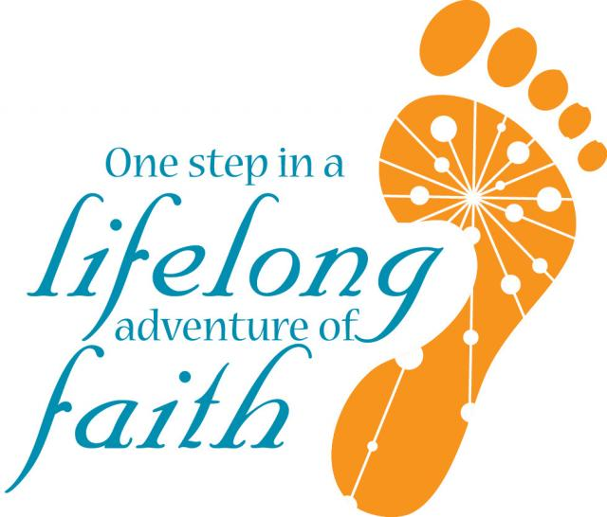
Talks With Tammy
“You Are Part”

YY

I spoke with someone the other day who was concerned that they weren’t doing enough for the church.
Having had just signed up to do a month of garbage duty, this was doable with a busy schedule
Yet, there was doubt, questioning the value of the commitment. Was it enough?
I think we all, at some time or another, have felt the same way. And that is sad. In today’s society, we see so much big, bold and over the top, that we sometimes forget about the support system underneath. The foundation.
There is a new house being built next to our home. It has been exciting to see the work being done. The frame of the house is going up quickly, a lot quicker than the foundation was laid.
Why? Because the foundation is made up of bricks and mortar. One brick laid at a time, is what holds the building in place. The understructure that supports what is built atop.
Each of you, are part of the foundation of the Castile United Church of Christ. This church depends on volunteers for just about everything that goes on in the building and through the outreach. Big or small.

Flowers on the Alter
Communion Preparation
Repairing a broken table
Fireside Chats
Decorating Committee
St. Pauly’s Shed
Weekly Greeters
Elder of the Month
Choir and Bell Choir
Teaching Sunday School

Technology Team
Facebook Recording
Board of Trustees
Unplugging a Toilet
Board of Elders
Stewardship
Funeral Receptions
Women’s Fellowship
Susan’s Comfort Care
Missions Committee
Christmas Family Gifts
Food Pantry: Shopping or packing
Meals & Missions
Personnel Committee
Winding the Tower Clock
Monthly Brunch
Lighting Candles on the Advent wreath
And….. Garbage Collection!!

Take away the commitment to any of these (and more), the foundation to this church is weakened.

“So, you are no longer outsiders and strangers. You are citizens together with God’s people. You are also members of God’s family. You are a building that is built on the apostles and prophets. They are the foundation. Christ Jesus himself is the most important stone in the building. The whole building is held together by him. It rises to become a holy temple because it belongs to the Lord. And because you belong to him, you too are being built together. You are being made into a house where God lives through his Spirit.”

Ephesians 2:19-22 (NIRV)

What you do matters! So please, believe in your own worth and let God show you how to build on it.
Contributed by Tammy!

Church Directory
Pastor: Tammy Lathan
Pastor Tammy’s Office Hours:
Tuesday & Thursdays: 8:00 AM - 2:00 PM
Wednesdays – By Appointment
Pastor Tammy’s Cell: (585) 969-0695
Church Phone: (585) 493-2840
Church E-mail: Castile_UCC@yahoo.com
Website: www.castileucc.com

Administrative Coord.: Marlene Loomis - 493-2968
Church Office Hours:
Tuesday – Friday 8:00 AM-2:00 PM
Church Moderator: Dennis Miller - 493-2743
Bd. of Elder Chair: Bonnie Miller - 237-3958
Bd. of Trustees Chair: Scott Chamberlain -752-3454
Custodian: Brooke VanEpps – 322-4676 (New)
Director of Music: Barb Meyer - 322-7396
Supt. of Build/Grounds: Greg VanSlyke – 322-0276

Facebook Live
Most of our worship services can be viewed on Castile UCC Facebook Live or you can view it anytime at your leisure for up to 30 days.


Volunteers Needed:
For a Sunday Morning Facebook Team. If you are able to help out with recording our Sunday Morning worship, please contact Pastor Tammy.
The goal is to put together a monthly schedule of volunteers. Step by Step instructions make the easy. Thank you!

Advent: Hope, Peace, Love, Joy

Dec. 3- 1st Sunday of Advent
(The Prophets' Candle, symbolizing Hope)
“Gift Sunday for Angel Action”
6:00 PM- Blue Christmas Service (In person or Facebook Live)

Dec. 10- 2nd Sunday of Advent
(The Bethlehem Candle, symbolizing Faith)
Christmas Pageant - “The First Christmas” & Birthday Party for Baby Jesus

Dec. 17- 3rd Sunday of Advent
(The Shepherds' Candle, symbolizing Joy)
Guest Speaker, Sue Russell

Dec. 24- 4th Sunday of Advent
(The Angel's Candle, symbolizing Peace)
10:00 AM- Worship Service

*6:30 PM- Christmas Eve Candlelight Service
(The Christ Candle, symbolizing HIS birth)

Dec. 31- Christmastide



Newsletter Deadline
All newsletter articles for the “United Flyer” are due by the 15th of each month and are at the discretion of the church office. We welcome your submissions.

"Blue Christmas?”
Holiday gatherings and festivities can be painful for many people in our congregation and community. With a growing attentiveness to the needs of people who are “blue” at Christmas, we are reaching out with a Blue Christmas Service on Sun., December 3 at 6:00 PM. You are welcome to join us at the Castile UCC in person or Facebook Live.
Coping with a loss that puts a question mark over the future can cause sorrow and stress.
Our Blue Christmas Service is reflective, accepting where we are, and offering healing and hope.

Christmas Poinsettias
$10.00
Deadline: December 17
In Memory Of:______________________________
In Honor Of: ______________________________
Given By:___________________________________



‘Wreaths Across America’

This year, National ‘Wreaths Across America’ Day will be held on Saturday, December 16, 2023.
Our Pastor, Tammy Lathan and her husband Ron, will join the more than two million volunteers and supporters who will gather to Remember, Honor and Teach at more than 4,000 participating locations in all 50 states, at sea and abroad. Thank you to Sue Russell for preaching while Pastor Tammy is away.

December Altar Flowers
Advent Display & Christmas Poinsettias

December Brunch
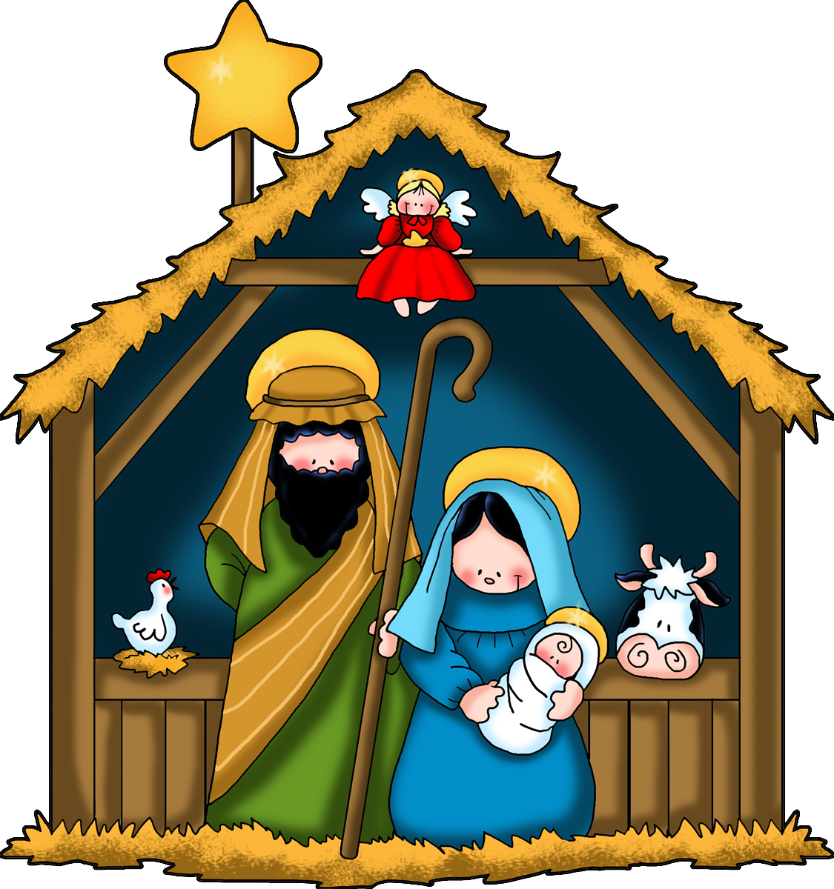
Sun., December 10 - Christmas Pageant Followed by a “Birthday Party for Jesus” held in the Embling Dining hall.

Christian Education News

Sun., December 10
Sunday School Christmas Pageant
“The First Christmas”

Sun. Dec. 3- “In the Potter’s Hand”
10- No Sunday School – Pageant Sunday
17- “The Light of the World”
24/31- No Sunday School 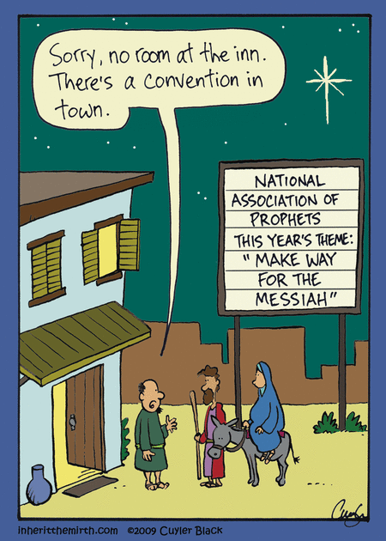
Board of Elder News
The BOE met on Thursday, November 2. The business we covered was: Angel Action Christmas Families, the return of Advent Fireside Chats beginning on November 29, the Blue Christmas Service on December 3 at 6:00 PM, Veterans Day Service, poinsettias for Christmas, recommendations to Nominating Committee, Tammy’s coverage for December 17th when she attends ‘Wreath Across America’ and the new time of 6:30 PM for the Christmas Eve Service.
As usual, I invite you to voice any concerns you may have regarding your church to one of the BOE members or Pastor Tammy. We are charged with the job of presenting a Holy Spirit filled service to you our brothers and sisters in Christ.
Merry Christmas to you all and may the blessings of this most Holy time of year rest upon you all.
Bonnie Miller BOE Chairperson
Missions News
SERRV Items for Sale
Remember this missions project when looking for unique Christmas gifts. Thank you in advance for supporting this project.

Scrap Metal Mission
cast iron copper stainless steel steel brass aluminum lawn mowers electric motors old machinery power tools hand tools batteries
NO: T.V.’s, computers, air conditioners, freezer, refrigerators (nothing with Freon in it.)
Contact Chuck Klein at 567-8204 for pick up.

The Christmas Fund
Ingathering will be on December 17

Giving to the Christmas Fund gives you an opportunity to be a part of a ministry that cares for the active and retired clergy and lay persons of the United Church of Christ.

Castile UCC Food Pantry
The Food Pantry is open to residence in the Town of Castile and may be visited monthly.

Contact the church office at 493-2840 to set up an appointment.

Board of Trustees News
We are currently seeking a new Church Treasurer

Job Description:
Requirements
- Bookkeeping/Accounting background
- Working knowledge of Microsoft including Word and Excel
- Maintain G/L, P/L and budget using Excel and/or Quickbooks
Duties
- Record all deposits to proper accounts
- Administer deposit accounts (General Fund, Perpetual Fund) in interest accounts when available
- Administer and pay all invoices as approved by the Board of Trustees
- Attend monthly Trustee meetings to report financial status of church
- Balance all bank statements monthly
- Oversee payroll duties including employee checks, track and pay fed and state W/H and FICA
- Prepare and file quarterly payroll reports
- Prepare and file workers comp and disability reports
- Oversee worker comp and disability claims
- Prepare and present reports for council meetings
- Prepare all reports for annual audit
- Participate in the preparation of annual budget with Pastor and Trustee Chairman

If you are interested, please contact Mark Barber (259-9421)
St. Pauly’s Shed - What TO Donate: Used clothing, shoes, belts, purses, linens, blankets, curtains, and stuffed animals.
Church Rental Fees:
Holiday Parties? Family Gatherings?

We would like to remind you that the Embling Dining Hall is available for rent.
Member fee is $50.00 and non-members $100.00. This includes use of the church dining room, kitchen, handicap accessible bathroom, handicap lift, several refrigerators for food, 10 burner stove with two large ovens, and a Bunn coffee maker.

NOTE: As we no longer have trash service at the church. You will need to take your trash home with you. Thank you!

Thank You’s
To everyone who donated food items or paper bags for our Food Pantry. The Food Pantry was able to provide 15 Thanksgiving Dinners.
To DeLaval of Castile, for donating 7 turkeys for our Food pantry clients.
To Castile UCC Women’s Fellowship for sending our Military Personal Thanksgiving cards with an Amazon gift card included.
To A. David Hurd for the donation of K cups for our coffee station.

Kindness…
“Sometimes it takes only one act of kindness and caring to change a person's life.”
Jackie Chan

December Birthdays
2 - Makenzie McCallister
3 - Steven Miller

3 - Nicole Granger
11 - Nolan Bannister
13 - Sarah Andrews
14 - Elizabeth (Davis) Frost
17 - Calvin Lindsey
18 - Steven Weaver
23 - Amber Sears
28 - Darla Huntz
30 - Lynn McNamara

December Anniversaries
8 - Theodore & Rose Ann Lindsay
28 - Steve & Barbara Meyer

Women’s Fellowship
Our Mission Statement:
“Through the belief in our Living God, our mission is to reach out and support families and individuals in need, by sharing ideas and creativity, using our time and talents to strengthen ties in the community.”

2023 Co-Chairs: Dawn Miller & Judy Goodenow
Co-Sec.: Mary Reagan & Marlene Loomis
Correspondence: Carol Becker
Treasurer: Cindy Feroleto

ALL WOMEN ARE INVITED TO OUR MONTHLY WOMEN’S FELLOWSHIP MEETINGS!
Mon., December 11, 2023 At 11:00 AM


3rd TUESDAY Of Each Month
‘Meals & Missions’

Next meeting:
Tue., Dec. 19 at 12:00 PM
You are invited to join us and to bring a dish to pass if able.

December Modern Parable:
“The Postman Lifted Us from Depression”


“Hats for the Homeless”:
We are accepting donations of Hats, Scarves, Mittens, and Socks to donate to the homeless.
Please feel free to drop them off in the church dining room. Thank you to those who have started bringing in those finished items.
If you are need of yarn to make these items, please contact the church.

We have already started to distribute some of these hats and scarves to the Adaptive Sports Foundation in Hunter, NY for them to use at their upcoming winter events for disabled Veterans.

Angel Quiz??
- There are about 10,000 angels in existence today.

Fact or Fiction

- God created angels on the sixth day of creation, the same day He gave life to man. Fact or Fiction?

- Angels never grow old, get sick, or die. Fact or Fiction?

- Angels are omniscient and know everything that will happen in the future.

Fact or Fiction?

5. Angels do not have physical bodies. Fact or Fiction?

6. Angels receive salvation through Jesus, just like Christians. Fact or Fiction?

7. The Bible only mentions two good angels by name. Fact or Fiction?

8. At the end of time, there will be a massive battle between angels and demons. Fact or Fiction?

9. When Satan fell, he brought one–third of the angels down with him. Fact or Fiction?

10. When people die, they become angels in heaven. Fact or Fiction?


(Answers are on the last page of the newsletter)
Military Personal Addresses
Michael Close
211 Brooks St, 3#9000
Box 467
Oceanside, Ca 92051

Lindsey, Tristin
775 Oswego Ave.
Fort Drum, NY 13602

Maj. Michael McLaughlin
6197 Harmonica Arch Lane
Colorado Springs, CO. 80924


Page, Christopher Michael
3742 Patriot Drive Apt. 201
Mail Box 5
Abilene, Texas 74606

Joshua Soble
2726 Trojan Ct.
Lenmore, CA 93245

Colonel Sara Torres
11537 Laurel Lake Square
Fairfax, VA 22030

**No address at this time, but please keep them in your thoughts and prayers.

Nathan Scott
Christopher Meyer (Deployed)
Brianna Miller
Tyler Smith
Daniel Scott (Deployed)



Annual Church Meeting is

Scheduled for Sunday, January 21, 2024

Congratulations to Timothy McMullen

Tim McMullen was inducted into the Section V Basketball Hall of Fame on November 6.


Tim coached the Varsity Boys Basketball program at Letchworth School for 31 years registering 334 career victories. He earned four Section V Coach of the Year awards and guided the Letchworth Indians to the Section V Class CCC title in 1999.

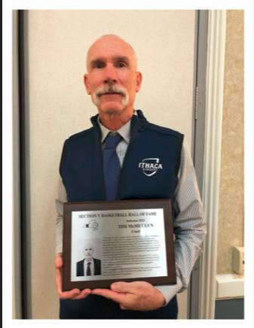

Single Mom’s “Breaking Bread” Club

Are you a single mom?
Join us for FREE dinners & fun programs for Moms & Kids.

In December there will only be one meeting of the :Breaking Bread” Singles Mom Club due to the holidays.
Sun., December 10 from 5:30 – 7:30 PM

Breezeway Barn
141 North Center Street
Perry, NY

Contact Jen Hall at jenhall@hiridge.gmail.com

“Light Up The Night”
Friday, December 1st
At 5:30 PM
held at the Castile Fire Hall.

Tree Lighting Ceremony & Dedication, Hot dogs, Cider, chips and cookies…Goodie Bags for Children, Horse drawn Wagon Rides & Santa



Breakfast With Santa
Sat., December 2 8:00 – 11:00 AM
$6.00 per person

held at Wolf Creek Event Center
50/50 Drawing & Chinese Auction


Angel Quiz Answers:
1. Fiction – The Bible never gives a precise count of all the angels.
2. Fiction – Since all the angels were there for the formation of the earth, it’s likely that angels are older than anything else we can see in the world.
3. Fact – As spiritual beings, angels will never experience physical sickness or old age.
4. Fiction – As created beings, angels have limitations. Their understanding of the future is restricted to whatever information God reveals to them.

5. Fact – While angels have taken human form occasionally, the Bible describes them as spirit beings (Psalm 104:4; Hebrews 1:14).
6. Fiction – Redemption is not a personal reality for angels, but they are excited about it on our behalf (1 Peter 1:12).
7. Fact – The only two good angels mentioned by name in scripture are Gabriel and Michael.
8. Fact – Revelation 12:7–8 states that Michael and his angels will be victorious over Satan and all his forces of darkness in the last conflict of the age.
9. Fact – We know this from Revelation 12:4, which describes how the dragon’s “tail drew a third of the stars of heaven and threw them to the earth.” That’s what the demons are: angels who joined Satan’s rebellion and became his servants.
10. Fiction – The Bible makes it clear that angels are a created class of beings and not spiritually progressed men.
Thank you Barb Meyer for submitting the Quiz.
