Castile United Church of Christ
P.O. Box 512 Castile, NY 14427
Church Phone: 585-493-2840
Church E-Mail: Castile_UCC@yahoo.com
www.castileucc.com
Pastor: Tammy Lathan
Tammy’s Cell Phone: 585-969-0695
United Flyer Editor: Marlene Loomis


October 2023 “United Flyer”

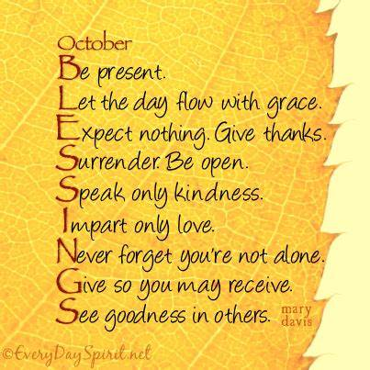

Talks With Tammy

Six Ways God Tests Your Faith & Character

By Rick Warren (Part 1 of 2)

God’s goal for our lives isn’t for us to be happy. It’s for us to grow in spiritual maturity.
Happiness comes from holiness. You will be happy for trillions of years when you get to heaven. But right now, you’re in the growing stage. And God is much more interested in your character than your comfort.
How does God grow you? Through tests. It’s like when you work out in a gym, where you test your muscles by lifting weights. The more you test your muscles, the more your muscles grow.
God builds your character in a similar way. But the tests that God gives you examine many areas in your life, such as your character and patience.
James describes it like this: “When troubles of any kind come your way, consider it an opportunity for great joy. For you know that when your faith is tested, your endurance has a chance to grow. So let it grow, for when your endurance is fully developed, you will be perfect and complete, needing nothing” (James 1:2-4 NLT).
The Bible tells us that when our faith is tested, our character will grow. Throughout Scripture, we see God test and grow the faith of some of the greatest biblical heroes. He uses these same six tests to grow our faith too.

Test #1 – A Difficult New Task
You’ll face this test many times in your life. God will tell you to do something that seems impossible. It’s like when God called Noah to build the ark. God may not ask you to build an ark, but he will ask you to reach for an impossible dream or to complete an impossible task.

Faith is facing the future without knowing “what” that task may be.

Test #2 – A Major Change
This is the “where” test. It’s a test that happens when a major change comes into your life and you don’t know where God is taking you.
God tells us to go - and changes everything in our lives in the process - but he doesn’t tell us where. God told Abraham to go from Ur to somewhere new without telling him where, and Abraham obeyed.
Maybe God wants you to serve in a different area than where you are currently serving. Or maybe he is telling you to sell your house, and you’re wondering, “But where am I going?”

Faith is following God’s leading without knowing “where.”

Test #3 – A Delayed Promise
This time you’re asking, “When?” God, when will you answer my prayer? When will our church grow? When will my marriage change?
You’re not the first to ask the question, “When?”
The Bible tells us Abraham had a similar experience: “Even when he reached the land God promised him, he lived there by faith - for he was like a foreigner, living in tents. And so did Isaac and Jacob, who inherited the same promise. Abraham was confidently looking forward to a city with eternal foundations, a city designed and built by God” (Hebrews 11:9-10 NLT).
Abraham based his life on God’s promises - not explanations. And his faith grew because of it.
Faith is waiting for God’s timing without knowing “when.”
To be continued….

Church Directory
Pastor: Tammy Lathan
Pastor Tammy’s Office Hours:
Tuesday & Thursdays: 8:00 AM - 2:00 PM
Wednesdays – By Appointment
Pastor Tammy’s Cell: (585) 969-0695
Church Phone: (585) 493-2840
Church E-mail: Castile_UCC@yahoo.com
Website: www.castileucc.com

Administrative Coord.: Marlene Loomis - 493-2968
Church Moderator: Dennis Miller - 493-2743
Bd. of Elder Chair: Bonnie Miller - 237-3958
Bd. of Trustees Chair: Scott Chamberlain -752-3454
Custodian: Brooke VanEpps – 322-4676 (New)
Director of Music: Barb Meyer - 322-7396
Supt. of Build/Grounds: Greg VanSlyke - 493-5874

Facebook Live
Most of our worship services can be viewed on Castile UCC Facebook Live or you can view it anytime at your leisure for up to 30 days.




Volunteers Needed:
For a Sunday Morning Facebook Team. If you are able to help out with recording our Sunday Morning worship, please contact Pastor Tammy.
The goal is to put together a monthly schedule of volunteers. Step by Step instructions make the easy. Please consider helping with this amazing Ministry. Thank you!

Preaching Schedule

Sun., October 1- World Wide Communion Sunday
Sun. October 8- Brunch Sunday
Sun., October 15- 20th Sunday after Pentecost
Sun., October 22- Church Council Sunday
Sun., October 29 - 22nd Sunday after Pentecost

Worldwide Communion Sunday

Worldwide Communion Sunday is a celebration observed by Christian denominations on the first Sunday of every October.
It promotes Christian unity and ecumenical cooperation. It is a day to remember that Jesus Christ is the Head of the Church and that all Christians are one in the body of Christ.
It is also a time to share what we have with brothers and sisters in need and to support Christians worldwide.

Newsletter Deadline
All newsletter articles for the “United Flyer” are due by the 15th of each month and are at the discretion of the church office. We welcome your submissions.

October Altar Flowers

October 1- Debbie Beeman
8- Connie VanSlyke
15- Jody Skinner
22- Betsy DeGroff
29- Marlene Loomis

New Address
Dale & Katie Cooley
525 Neptune Drive
Apt. 201
Clarksville, TN 30743

Brunch
Sun., October 8 – Provided by the Nominating & Stewardship Committees

Church Council Meeting
Our next Church Council meeting will be held on Sun., October 22 at 11:00 AM.
This is a very important Council Meeting as we will be voting on the 2024 Budget.
Please have your reports ready by Wed., October 18 to be copied, as this is a great time saver.

Board of Elder News
On September the 7^{th,} your Board of Elders met after having taken the months of July and August off. During those months, any concerns needing attention were dealt with by email.
We addressed summer attendance and found that there were no pressing issues during the months of July and August.
With Fall approaching this board will resume its regular monthly meeting schedule of the first Thursday of the month. Please remember the responsibility of this board is to offer you a spiritually based worship service every Sunday morning.
This board is here to address any concerns that the congregation may have re: the worship service. Please contact any board member with your comments and concerns.
With Christ's blessings our church continues to move forward praising the Lord and reaching out in love.
Bonnie Miller Chairperson

Board of Trustees News
Outside painting is completed – Thank you Brian Walton & Co. for completing the painting on the outside of our church.

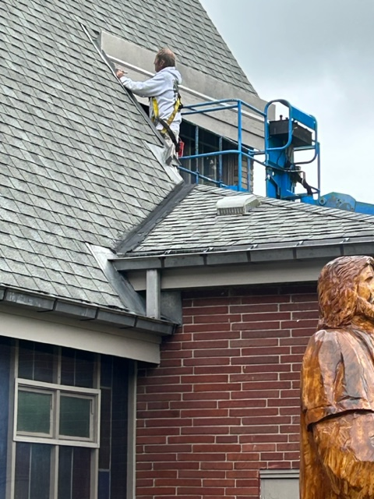

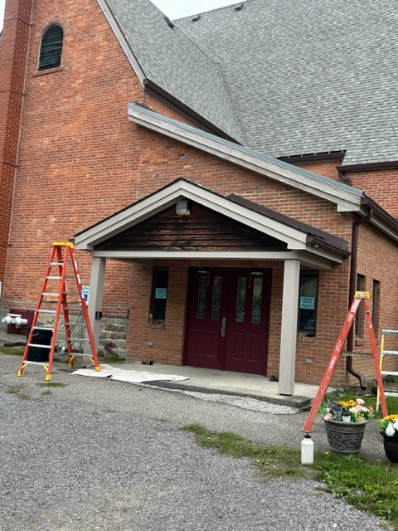

St. Pauly’s Shed
What TO Donate: Used clothing, shoes, belts, purses, linens, blankets, curtains, and stuffed animals.
What NOT to Donate: Furniture, electronics, household items, books, toys, rags, pillows or fabric scraps.

June - $192.86 August - $204.28
July- $144.42 September - $170.00

Church Rental Fees:
Wedding Showers? Holiday Parties?
We would like to remind you that the Embling Dining Hall is available for rent.
Member fee is $50.00 and non-members $100.00. This includes use of the church dining room, kitchen, handicap accessible bathroom, handicap lift, several refrigerators for food, 10 burner stove with two large ovens, and Bunn coffee maker.
NOTE: As we no longer have trash service at the church. You will need to take your trash home with you. Thank you!
Taking Out the Trash…
The Board of Trustees is looking for more people to be willing to sign up for taking the trash for a month. The Trash Shed is located outside the Baker Entryway.

Christian Education News
We will be using Sermons4kids as our curriculum again this year.

October 1 – “Moses Gets Water From A Rock”
8 – “The Ten Commandments”
15 – “The Golden Calf”
22 – “Pharisees Plot Against Jesus”
29 – “Love God and Others”

Missions News
Scrap Metal Mission
cast iron copper stainless steel steel brass aluminum lawn mowers electric motors old machinery power tools hand tools batteries
NO: T.V.’s, computers, air conditioners, freezer, refrigerators (nothing with Freon in it.)
Contact Chuck Klein at 567-8204 for pick up.

Neighbors in Need –
Ingathering on October 1 as part of Worldwide Communion Sunday.

In 2023, the Neighbors in Need
“BEHOLD!” theme continues.

This year’s focus is on environmental justice. Plastics, electronics, and other non-compostable wastes are being shipped across, and even tossed into, our waterways, launched into space, as well as buried in landfills. As people of faith, we believe these egregious acts are sinful and unholy. We must be better stewards of our planet!

Church Choir & Hand Bell Choir
All are welcome to join us in singing or playing/learning Hand Bells.



Castile UCC Food Pantry
The Food Pantry is open to residence in the Town of Castile and may be visited monthly.

Contact the church office at 493-2840 to set up an appointment.

The Castile UCC Food Pantry is looking ahead at the upcoming holidays. We are beginning to collect items for our Food pantry Thanksgiving boxes.

Items Needed:
Box Stuffing Mix Cranberry sauce
Canned vegetables Instant Mashed potatoes
Turkey Gravy Applesauce
Pudding/Jello mixes Dessert mixes
Cool Whip Pickles

Thanksgiving boxes will be packed the last week of October.

Thank You’s
To Patrick & Cindy Feroleto for cleaning all of the chairs in the Embling Dining Hall.
To Jen Wallace, Tony Harper & Bonnie Miller for our beautiful Fall decorations.
To Butch & Betsy DeGroff for donating fall pumpkins, corn stalks, mums, etc.
To Mark Barber for mowing the church lawn all season.
To Pastor, Tammy Lathan for taking charge of the front sign slides.
To Mike Rogers for putting a new coat of sealant on the Jesus Statue.
To Lynn & Chalene Miller for donating four Nativity Christmas plates.
Kindness…



Praying and Serving your Church
As Fall comes around, we start talking about budgets for the coming year, I ask that you prayerfully consider being on a Board or Committee.
As the Chair of Stewardship and Nominating Committees, I ask you to pray in advance that God will open your heart to serve our church.

Stewardship Comm. meeting:
Tuesday. October 3 at 6:00 PM.

October Birthdays
1 - Angelo Feroleto
3 - Charlie Miller
4 - Edwin Gunn
5 - Carol Becker
6 - Rose Anne Lindsey

8 - Christopher VanZandt
9 - Kathy Spencer
14 - Mark Everingham
17 - Darcie Ikeler
19 - Kathy Pitts
26 - Brandi Sears
28 - Donald Lockwood
29 - Sheri Brandes
30 - Patrick Feroleto
31 - Colleen Clark
31 - Kelcy Brandes

October Anniversaries
18 - Quinn & Barbara Bellamy
21 - Frank & Colleen Bean

Casual Walk Through Matthew’s Gospel
JOHN THE BAPTIST JUDGES IN LOVE
MATTHEW 3:4-12

“John’s clothes were made of camel’s hair, and he had a leather belt around his waist. His food was locusts and wild honey. People went out to him from Jerusalem and all Judea and the whole region of the Jordan. Confessing their sins, they were baptized by him in the Jordan River. But when he saw many of the Pharisees and Sadducees coming to where he was baptizing, he said to them: “You brood of vipers! Who warned you to flee from the coming wrath? Produce fruit in keeping with repentance. And do not think you can say to yourselves, ‘We have Abraham as our father.’ I tell you that out of these stones God can raise up children for Abraham. The ax is already at the root of the trees, and every tree that does not produce good fruit will be cut down and thrown into the fire. I baptize you with[a] water for repentance. But after me comes one who is more powerful than I, whose sandals I am not worthy to carry. He will baptize you with[b] the Holy Spirit and fire. His winnowing fork is in his hand, and he will clear his threshing floor, gathering his wheat into the barn and burning up the chaff with unquenchable fire.”
John the Baptist was a very sensitive man who was dedicated to the task he was born to fulfill. As we read these words from Matthew’s Gospel, we might be drawn to think differ-
ently. As he notices a number of Pharisees and Sadducees coming to be baptized, it appears he thinks they approach him for all the wrong reasons! But we should remember, John was not in any way attempting to judge them so as to place himself above them. “You brood of Vipers!” he called out to them. John was well aware that those religious leaders were “all talk but no action.” Accordingly, as he endeavored to jar their
minds he says, “Bear fruit worthy of repentance.” (We touched on what it meant to repent, TO TURN AROUND” in last month’s discussion.)

Repentance was and is commonly recognized as a vital requirement. for baptism. This repent-
ance was all-inclusive. It encompasses one’s total being which is to say, your actions need to follow your words. The Church has since adopted infant baptism, to formally join our children into the family of Jesus Christ.
It is THEREFORE VERY IMPORTANT THAT AT Confirmation OR ADULTHOOD, that the one baptized as an infant, accepts his or her baptism and makes confession before God.
John’s role was a tough role, and he went at it humbly and evidently with a high degree of success. In discussing the one who was to come after him, John the Baptist said that he was to be far mightier than me. In fact, John said that he was not worthy to carry the sandals of the one who was to come!
Matthew also speaks loudly about the timing of Christ’s coming. It is for me at least, as if John is saying: “Hey, wait a minute, do not let this be something you put off until tomorrow or days thereafter. Christ is coming! In fact, “His winnowing fork is in his hand…” Now, I have never used a winnowing fork, they were outdated by the time I was involved in harvesting. But I am sure Matthew knew one does not go around carrying a winnowing fork unless it is time to harvest! Jesus is not just coming. Jesus is here! Matthew prods us to grasp the truth that NOW is the time to embrace him. Now, TODAY is the time to become his disciple. YES, we who are followers of Jesus are called, as John the Baptist was called, to prepare the way for the coming of Jesus into the lives of others.

Peace, Love & Joy,
~ Clyde
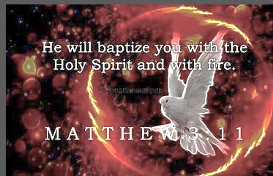

Single Mom’s “Breaking Bread” Club
Are you a single mom? Join us for FREE dinners & fun programs for Moms & Kids.


Sun., October 8 5:30 – 7:30 PM
22 5:30 – 7:30 PM

Breezeway Barn
141 North Center Street in Perry, NY
Contact Jen Hall at jenhall@hiridge.gmail.com

Letchworth Arts & Crafts Show & Sale
Columbus Day Weekend

October 7th, 8th, & 9th , 2023
At Perry Village Park

Presented by the Arts Council for Wyoming County
Shuttle buses are available.
Conversations With Kids
Teacher: Clyde, your composition on “My Dog” is exactly the same as your brother’s. Did you copy this?
Clyde: No sir; it’s the same dog.

Teacher: Harold, what do you call a person who keeps on talking when people are no longer interested?
Harold: A teacher.

Teacher: Donald, what is the chemical formula for water?
Donald: H I J K L M N O
Teacher: What are you talking about?
Donald: Yesterday you said it was H to O.

Teacher: Glen, how do you spell crocodile?
Glen: K - R - O - K - O - D - I - A - L
Teacher: No, that’s wrong.
Glen: Maybe it’s wrong, but you asked how I spell it.

Teacher: Maria, go to the map and show us where North America is?
Maria: Here it is.
Teacher: Now class, who discovered America? Class: Maria.
Women’s Fellowship
Our Mission Statement:
“Through the belief in our Living God, our mission is to reach out and support families and individuals in need, by sharing ideas and creativity, using our time and talents to strengthen ties in the community.”

2023 Co-Chairs: Dawn Miller & Judy Goodenow
Co-Sec.: Mary Reagan & Marlene Loomis
Correspondence: Carol Becker
Treasurer: Cindy Feroleto

ALL WOMEN ARE INVITED TO OUR MONTHLY WOMEN’S FELLOWSHIP MEETINGS!

Mon., October 16, 2023 At 11:00 AM
(PLEASE NOTE: CHANGE IN DATE.)


BAKED FOOD SALE PROCEEDS:
$418.50!


3rd TUESDAY Of Each Month
‘Meals & Missions’

Next meeting:
Tues., Oct. 17 at 12:00 PM
You are invited to join us and to bring a dish to pass if able.

October Modern Parable: “A Hole in the Fence”

Women’s Fellowship has been very busy over the Summer.

We donated 5 lap robes/throw size quilts to Crossroads House in Batavia and 12 more ‘I SPY Quilts’ to the Wyoming County Sheriffs Dept. who distribute them to children during emergencies.


Suzannes Comfort Care Home:
Thank you to all who donated items for Suzanne’s Comfort Care Home in Perry, NY. These items are needed for the home to continue their important mission.

“Hats for the Homeless”:

We are accepting donations of Hats, Scarves, Mittens, and Socks to donate to the homeless.
Please feel free to drop them off in the church dining room.
If you are need of yarn to make these items, please contact the church.
Monthly Home Touch Newsletters:
Did you know that the Women’s Fellowship subscribes to a monthly Home Touch newsletter designed especially for older shut ins?
If you are currently not on our mailing List, and you would like to receive this, free of charge, please contact Marlene Loomis in the church Office at 585-493-2840 or email castile_UCC@yahoo.com.

Women’s Fellowship Prayer Brunch

Sat., October 28, 2023
10:00 AM

Theme is:
“A Bead and a Prayer”

Host Church: Castile UCC
Presenter: Pastor Tammy Lathan

Thank you to Castile UCC, Pike Community Church and Gainesville Methodist Church for hosting this event.

Military Personal Addresses
Michael Close
211 Brooks St, 3#9000 Box 467
Oceanside, Ca 92051

Anthony Feroleto
142 Droms Rd.
Glenville, NY 12302

Lindsey, Tristin
775 Oswego Ave.
Fort Drum, NY 13602
Maj. Michael and Lindsay McLaughlin
6197 Harmonica Arch Lane
Colorado Springs, CO. 80924

Page, Christopher Michael
3742 Patriot Drive Apt. 201 Mail Box 5
Abilene, Texas 74606

Joshua Soble
2726 Trojan Ct.
Lenmore, CA 93245

Sara Torres
11537 Laurel Lake Square
Fairfax, VA 22030

**No address at this time, but please keep them in your thoughts and prayers.

Nathan Scott Christopher Meyer
Brianna Miller Tyler Smith
Daniel Scott

Office for the Aging Medical Transportation
Need a ride to Medical appt. Meredith Lindsay is the contact and also the driver for in-County medical trips. 585-786-8833
2 x/wk in county
1 x/month out of county (different driver)

Between the hours of 8:00 AM – 4:00 PM,
3 days' notice - exceptions made
All appointments should not be made for after 2:00 PM.

No charge/Donations accepted



