Maundy Thursday

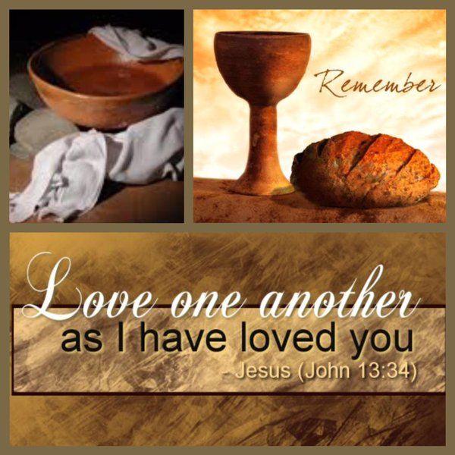

Thur., April 17, 2025
6:30 PM

The Last Supper
The Meal

Lighting of Candles
Partaking of The Last Supper

Prayer of Consecration

Hymn: "Let Us Break Bread Together"

Let us break bread together on our knees, Let us break bread together on our knees.
When I fall on my knees with my face to the rising sun, O Lord, have mercy on me.
Sharing the Bread

Let us drink wine together on our knees, Let us drink wine together on our knees.
When I fall on my knees with my face to the rising sun, O Lord, have mercy on me.

Let us praise God together on our knees, Let us praise God together on our knees.
When I fall on my knees with my face to the rising sun, O Lord, have mercy on me.

Sharing the Wine

Prayer of Thanksgiving

“Blest Be the Tie that Binds”

Blest be the tie that binds, Our hearts in Christian love;
The fellowship of kindred minds Is like to that above.
We share our mutual woes, Our mutual burdens bear;
And often for each other flows, The sympathizing tear.
When we asunder part, It gives us inward pain;
But we shall still be joined in heart, And hope to meet again.

Please join us in the Sanctuary for our Maundy Thursday Service.

2026 Maundy Thursday Service of Reflection

Prelude Music Invitation
Castile UCC Choir: “Abide With Me”
Readings and Extinguishing of Lights

First Reading: Shadow of Betrayal - Matthew 26:20-25 (NIV)

Second Reading: Shadow of Desertion - Matthew 26:31-35 (NIV)

Third Reading: “Agony of the Soul” - Luke 22:39-44 (NIV)

Fourth Reading: “Unshared Vigil” - Mark 14:32-41 (NIV)

Fifth Reading: “Father, the Hour is Come” - John 17:1-6 (NIV)

Sixth Reading: “That They May All be One” - John 17:15-22 (NIV)

Seventh Reading: “Arrest in the Garden” - John 18:1-5 (NIV)

+ + + + + Dropping of the Coins + + + + +

Eighth Reading: “Shadow of the Cross” - Mark 15:16-20 (NIV)

+ + + + + Pounding of Nails + + + + +

Final Reading: Matthew 27: 50-54

“O Sacred Head Now Wounded” – Interpretative dance by Jackie Swaby

Please take time for reflection, as you journey towards Easter…

