Castile United Church of Christ
P.O. Box 512 Castile, NY 14427
Church Phone: 585-493-2840
Church E-Mail: Castile_UCC@yahoo.com
Pastor: Tammy Lathan
Tammy’s Cell Phone: 585-969-0695
United Flyer Editor: Marlene Loomis

September 2025 “United Flyer”



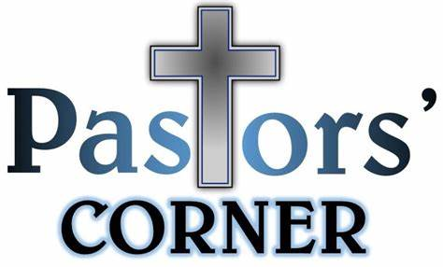

The Dangers of Drifting
As interesting as it may sound, it is somewhat ordinary to hear news stories about people who drift out to sea. In 2024, two such incidents made worldwide headlines.
First, a woman in a swim ring drifted out to sea while swimming at a Japanese beach. She was rescued some 36 hours later, 50 miles out in the Pacific Ocean, and was lucky to have survived despite the dangers of the sea.
Secondly, a Russian man was rescued after drifting in a small inflatable boat in one of the coldest seas in East Asia. Sixty-seven days earlier, he, his brother and nephew, set out on a whale-watching trip only to be left adrift after the boat motor failed. Unfortunately, his brother and nephew did not survive.
Just as these people experienced the life-threatening reality of drifting out to sea, we have the abstract warning found in Hebrews 2:1 “That is why we must hold on all the more firmly to the truths we have heard, so that we will not be carried away.”
Written to Christians, the author cautions believers to beware of slowly, subtly, drifting from the safe shores that are in Christ and becoming separated from God.
Many things can be the cause of spiritual drifting. The desire for pleasure, the weariness of life, the familiarity of religious practice, and the influence of society can drag us away from the safe harbor of the Lord.

However, spiritual drifting is preventable by paying attention to our position in the faith. The bible says that we must be diligent to make our calling within the gospel sure and steadfast, all-the-while keeping our eye on the shoreline, which is the upward call of God in Christ Jesus.
Jay Launius (2024) Maud Church of Christ Maud, TX

Church Directory
Pastor: Tammy Lathan
Pastor Tammy’s Office Hours:
Tuesday & Thursdays: 8:00 AM - 12:00 PM
Wednesdays – By Appointment
Pastor Tammy’s Cell: (585) 969-0695
Church Phone: (585) 493-2840
Church E-mail: Castile_UCC@yahoo.com
Website: www.castileucc.com

Administrative Coord.: Marlene Loomis - 493-2968
Church Moderator: Dennis Miller – 233-8933
Bd. of Elder Chair: Cindy Feroleto – 493-2696
Bd. of Trustees Chair: Ron Lathan – 703-5286
Custodian: Leilani Helmer - 813-4164
Director of Music: Barbara Meyer - 322-7396
Supt. of Build/Grounds: Greg VanSlyke - 493-5874

Newsletter Deadline
All newsletter articles for the “United Flyer” are due by the 15th of each month and are at the discretion of the church office. We welcome your submissions.

Clerk’s Records
Births
Rowan Marc Buckel - born on June 22, 2025
Parents: Jason & Lindsay Buckel
Grandparents: Edwin & Lisa Gunn
Great Grandmother: Joyce Rugg

Alana Leslie DeGroff – born on July 8, 2025
Parents: Dean & Macy DeGroff (who live in M)
Great Grandparents: Leslie (Butch) & Betsy DeGroff

Deaths:
Joan M. Coffey – died July 1, 2025


August Altar Flowers
3- Larry Rogers (In memory of Wendy Rogers)
10- Rebecca Vasile (In memory of Alfred Loomis)
17- Sue Barber
24- Sandy Graham
31- Brenda Whitmore

Church Rental Fees

Member Fee: $50.00
Non-Members Fee: $100.00
This includes use of the church dining room, kitchen facilities, handicap lift and bathroom.
NOTE: We no longer have trash service at the church. If you rent the church, you will need to take your trash home with you. Thank you!
Book your event early for the best choices!
Brunches
No Brunch will be held in August.

UCC Recognition & Education Sunday
On Sunday, June 22 we recognized our 4th graders and presented them with a Bible.
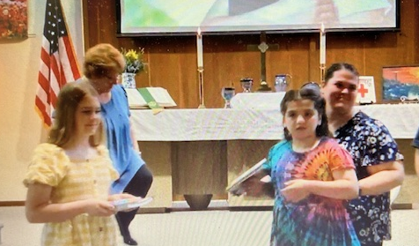
Our Fourth Graders

Naomi Bellamy Emily Brandes
Our 2025 Graduating Seniors
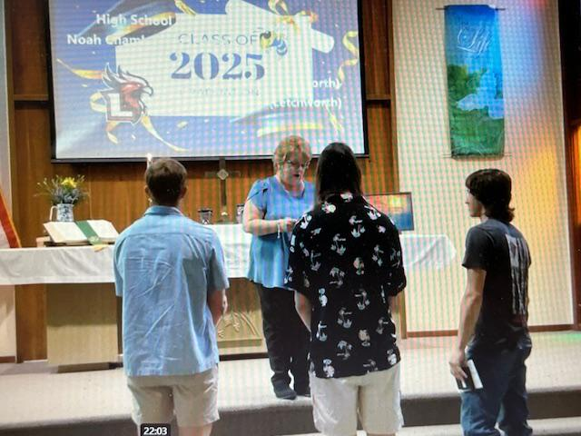Ayden Miller Gabrielle Sommers Noah Chamberlain
Our UCC Celebration Cake
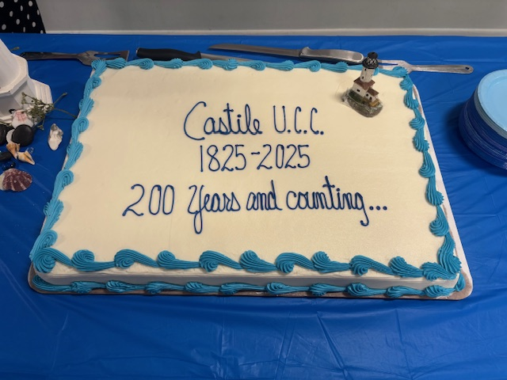

Representatives from The Genesee Valley Assoc. of the NY Conference
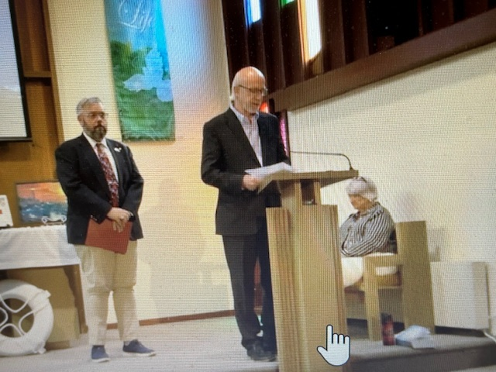
Rev. Ryan Henderson & Joseph Robinson
GIFTS
“What I would give you, if it were mine to give?
I would give you quiet courage, the steadiness beneath your feet
when you face whatever lies ahead on your course through life.
I would give you a glad heart, the center of joy, the sense of balance in all you say and do.
I would give you the bright vision, the clear view of what you hope,
the invitation to keep drawing closer to what you dream. I would give you these, for they are what I need as well:
quiet courage, a glad heart, a bright vision.
These three gifts I will keep praying – for me, for you, for all of us
who have set sail on this timeless sea together.
May we each have these gifts of the Spirit, in just the right way we need them,
at just the moment we need them most.
And may they empower us to sail on, sail on toward the light of dawn.”

(Rev. Steven Charleston, Episcopal Bishop)
submitted by Barbara Meyer

Missions News
Scrap Metal Mission
cast iron copper stainless steel steel brass aluminum lawn mowers electric motors old machinery power tools hand tools batteries
NO: T.V.’s, computers, air conditioners, freezer, refrigerators (nothing with Freon in it.)
Contact Chuck Klein at 567-8204 for pick up.

Castile UCC Food Pantry
The Food Pantry is OPEN to any resident in the Town of Castile and may be visited monthly.

Please contact 585-493-2840 to set up an appointment. The first and second Tuesdays and Thursdays are pick up days.

See the bulletin board in the Embling Dining Hall for a list of items needed for the Food Pantry.

Board of Trustees News
St. Pauly’s Shed latest check was for $152.19.
What to Donate: Used clothing, shoes, belts, purses, linens, blankets, curtains, and stuffed animals.



The paving of our church parking lot is scheduled for the end of JULY.

Stay tuned for more details.

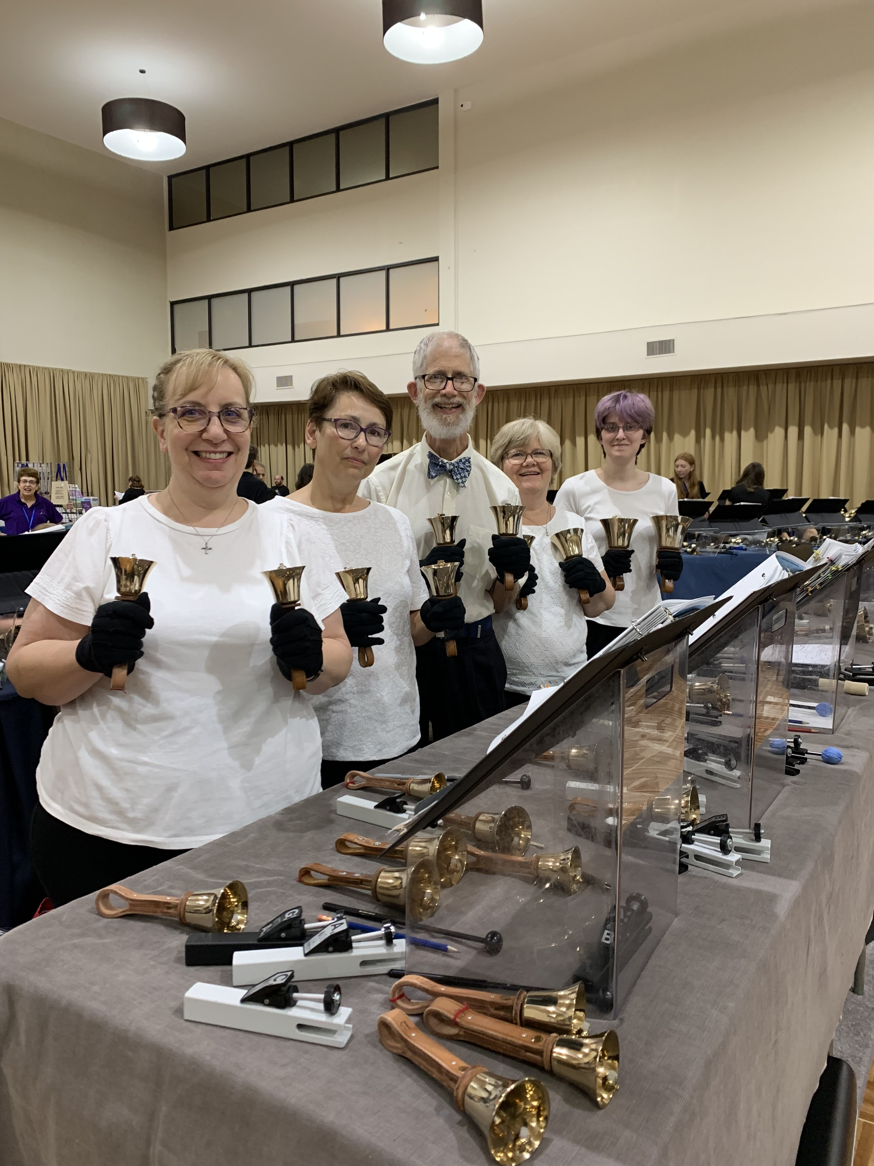
Our Handbell Choir at the Handbell Choir Festival in Pennsylvania
Thank you’s
To Beverly Edwards for returning another $16.05 in pop cans. Please keep them coming.
To Jim Loomis for replacing the batteries in the smoke detectors.
To J. D. Andrews for regrading our church parking lot. (Those potholes were EPIC!) The Paving project is slated for the end of July.
To Greg VanSlyke for checking on our drainage, due to all the heavy rain and for ‘rodent removal’.
To Jen Wallace for all the special Sunday Decorating. It really enhances our Worship Experiences together.
To ALL THOSE who helped water the new plantings, especially Ron Lathan & Greg VanSlyke for devising our automatic watering system!!!
To Timothy (and Marcia) McMullen for joining us on July 13 so Tim could be our Guest Speaker.

August Birthdays
2 - Mark Barber
3 - Lisa Gunn
5 - Erin Reiter
6 - Mark VanZandt

7 - Esther Dake
7 - Sandy Graham
10 - Michael Swarthout
11 - Rebecca Vasile
11 - Judy Goodenow
17 - Owen Beck
19 - Brianna Dake
21 - Dawn Folts
25 - Jenifer Wallace
26 - Karen Anderson
27 - Roger Goodenow
27 - Barbara Brown
30 - Allana Fuller

August Anniversaries
6 - Tim & Valerie Miller
13 - Tyler & MeLynda King
14 - Ed & Lisa Gunn
18 - Gordon & Jill Davis

21 - David & Barbara Brown
22 - Dan & Sheri Brandes
22 - Phillip & Kim Shappy
27 - Larry & Carol Becker (55 years!)
31 - Phil & Becky Vasile
31 - Gary & Brenda Whitmore



Beginnings
- Isn’t it nice to think that tomorrow is a new day with no mistakes in it yet?” – L. M. Montgomery
- “Every morning’s dew is a fresh breath of a new beginning.” – Jessica Edouard
- New beginnings are often disguised as painful endings.” – Lao Tzu
- “You are never too old to start over. Every day is a chance to make changes to create the life we want. – Karon Waddell
- “Each sunrise brings a new day filled with new hopes for a new beginning.” - Debasish Mridha
Submitted by Greg VanSlyke

200 Years and Counting… 1825-2025

The Bicentennial Committee would like to invite you to share about WHAT the church has meant to you over the years... (You do not have to include your name.) It is our hope to print these into a booklet to pass out at our final event in November.

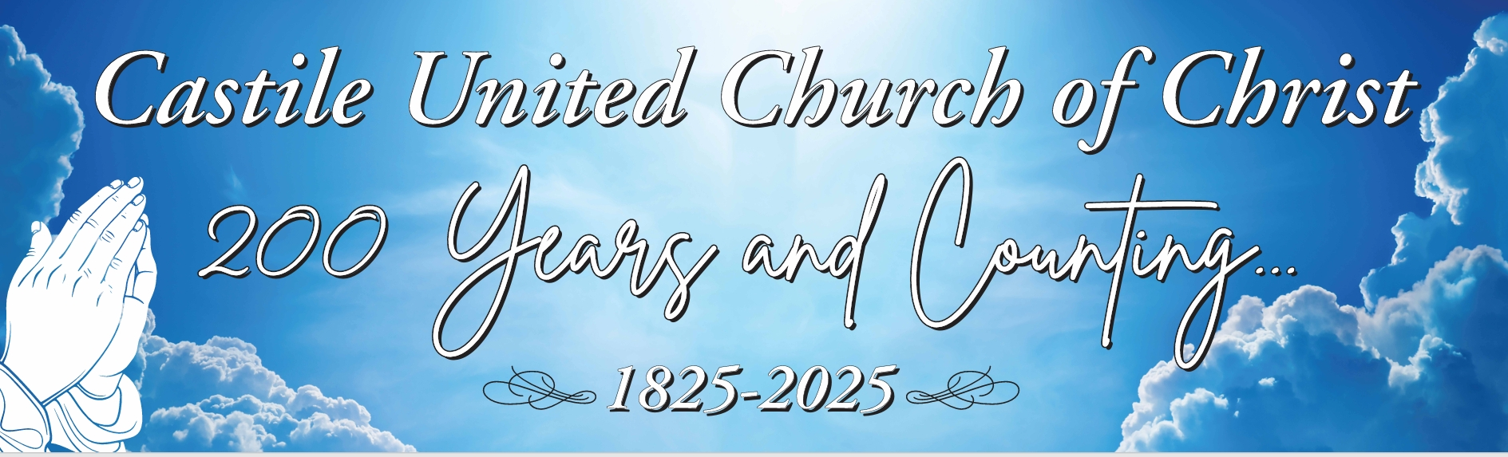

UPCOMING Bicentennial Events

September – Dedication of the New Landscaping

October - Fall Music Concert
Saturday, October 25 at 3:00 PM at the church.

Featuring the Castile UCC Choir & Handbell Choir, and Mr. A. David Hurd will be performing on the organ. (Including a history of our organ and a demonstration of all the features.)

November – All Church Harvest Dinner
Sunday, Nov. 16, 2025, following Church Service. Please bring a dish to pass and your own table service. We will also present the congregation with a Special 3 D printed Bicentennial Ornament.
Women’s Fellowship Our Mission Statement: “Through the belief in our Living God, our mission is to reach out and support families and individuals in need, by sharing ideas and creativity, using our time and talents to strengthen ties in the community.”
2025 Co-Chairs: Judy Goodenow & Michelle Post Co-Secretaries: Marcy VanZandt & Joan Maddison Correspondence: Carol Becker & Beth Pond Treasurer: Cindy Feroleto
Home Touch Newsletter
This is a monthly newsletter filled with scriptures, puzzles, Bible stories, etc. If you would like to be added to our mailing list, please contact the church office at 585-493-2840.

New Fundraiser for Women’s Fellowship

Do you have items you no longer need or want??? Instead of HOLDING a Rummage Sale, Castile UCC Women’s Fellowship has an arrangement with 2nd Time Around Consignment Shop
in Leicester, NY.

You can drop your “Treasurers” off and ask them to be credited to the Castile UCC – Women’s Fellowship when they sell it. New or gently used items ONLY. Please make sure your items are clean before dropping them off.

By Appointments Only – 585-382-5064.
Please call if you have questions.

Media, Pop Culture & Collectables
Action Figures Albums – Classic Rock

Albums – Country Arcade Games (Full Size)
Boom boxes Calculators
Collectable Cards Die Cast toys
Disney & Pixar DVD’s
Board Games (must be complete)
Hamm Radios Harry Potter
Hot Wheels I Pods & MP3 Players
Lego’s Metal Bodied Camera’s Musical Instruments (No Pianos)
Models Morton Salt Memorabilia
Pop Culture Puzzles (must be complete)
Record Players Peanuts, Mickey Mouse, etc.
Sports cards Stereo equipment
VCR’s & Rewinders VHS Players
Video Games
Vintage & Antique Toys
Vintage & New Buffalo Bills items
Vintage & New Buffalo Sabers items
Vintage Concert T-Shirts
Vintage T-Shirts

Holiday:
Animatronics Blow Molds (All)
Ornaments Seasonal items
Vintage Halloween Vintage Christmas

Vintage and Antiques:
Cast iron pots Ceramic crocks
Die Cast miniatures Galvanized tubs
License Plates Lighters
Local History items Old Crates
Pocket knives Pocket Watches
Political Memorabilia

Household/Misc.
American Décor Beer Stiens
Book Shelves Brand Name Tools
Coin Collections Corner Hutches
Curio Cabinets Decorative Ladders
Garden/Lawn Furniture Hall Trees
Hoosiers Hunting Gear (All)
Jewelry (of all kinds) Jewelry Boxes
Floor Lamps Lanterns
Mid Century Modern Pewter Figures
Pocket knives Purses
Pyrex (All) Salt & Pepper Collections
Silverware
Small Appliances (New/Lightly Used)
Small Furniture (End tables. Etc.)
Snowglobes
Taxidermy

Save the Date:
Women’s Prayer Brunch
Host Church: Castile UCC

Theme: ‘Prayer is the Key’


“And all things, whatsoever ye shall ask in prayer, believing, ye shall receive.”

~ Matthew 21:22

Sat., October 18 – 10:00 AM
Speaker: Tammy Lathan

Military Personal Addresses

Lt. Col. Michael McLaughlin - NEW
7184 Sky Meadow Drive
College Grove, TN 37046

Page, Christopher Michael
3742 Patriot Drive Apt. 201
Mail Box 5
Abilene, Texas 74606


SGT Nathan Scott
110 Vibbert Avenue
Box 53476
Fort Moore, GA 31995

Chief Petty Officer Joshua Soble
2726 Trojan Ct.
Lenmore, CA 93245

Colonel Sara Torres
11537 Laurel Lake Square
Fairfax, VA 22030

**No address at this time, but please keep them in your thoughts and prayers.

Christopher Meyer Briana Miller Tyler Smith

