Castile United Church of Christ
P.O. Box 512 Castile, NY 14427
Church Phone: 585-493-2840
Church E-Mail: Castile_UCC@yahoo.com
Pastor: Tammy Lathan
Pastor Tammy’s Cell Phone: 585-969-0695
United Flyer Editor: Marlene Loomis

January 2026 “United Flyer”

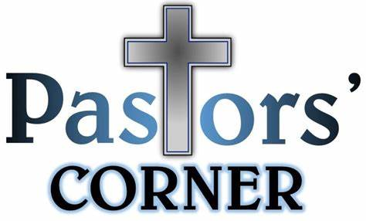

Easter and its relationship to Advent…
By Rev. Dr. Brian Janssen
It may seem strange given this is the December Newsletter, but I would like to write briefly about Easter and its relationship to Advent. You may think I have gone off the rails, after all Advent relates to Christmas not Easter.
Christmas, and the massive thing it has become culturally, has become the central event of the Christian year. It is certainly a time to celebrate.
We celebrate the birth of our Savior, but I think also we are celebrating much more. Whatever may have been worrying us as the school year began begins to ebb.
The kids may be back into a routine, and even when it comes to gift giving, which is never easy, at least we may begin to recognize what people in our lives need as we connect with them more deeply.
So, you will never see me or hear me fighting over Christmas, I love it, in all its guises, and I love celebrating it in church, especially this year.
It is important to note that if, you removed the Christmas from the Bible (and I am not suggesting we do,) you would lose one chapter in Matthew and two in Luke.
If you removed Easter, you wouldn’t have a New Testament. Advent is surely a time of waiting, with our purple liturgical colors on full display, we know that as the color suggests, we are somewhere in between darkness and light.

Advent belongs to the Old Testament as we await the birth of the one who will save us all. But while we wait for the spontaneous inbreaking of grace into the world in Jesus, we should not be afraid to take time and remember the fact that the grace experienced in the birth, life, ministry, words, death, and resurrection is always reflected in the church.
It is not just when the church celebrates the miracle of Christmas, but when it experiences God’s justice rolling down like never ending waters.
That justice, brought to us in Jesus, is what we seek and is what begins at Christmas time, as celebrate the ushering in of God’s kingdom.
This happens in small ways as well as large. It happens in the building of relationships, the integration of grief into our lives, the budding signs of hope in a broken world, giving a gift.
The small, local experiences are just as capable of telling the world about our Savior as any wide scale program or policy can do.
A Christmas birth leads us to Bethlehem, it leads to a cross, and an empty grave. It leads us to one another and new ways of living in grace, peace, and love.
Have a wonderful Advent season! Have a Merry Christmas!
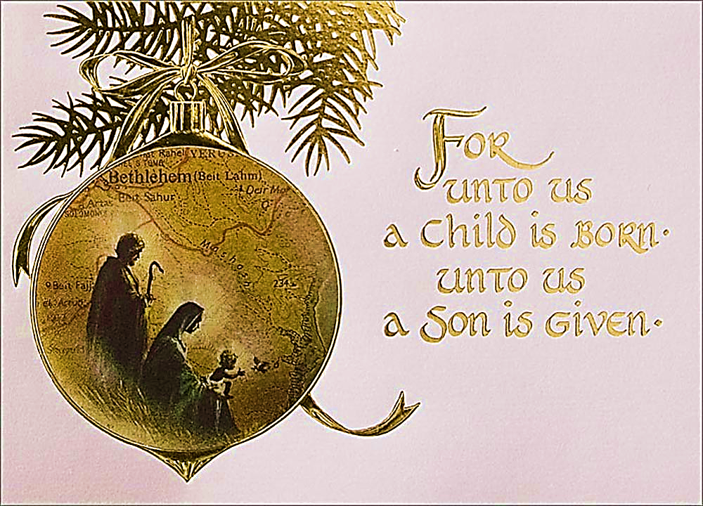

Church Directory

Pastor: Tammy Lathan
Pastor Tammy’s Office Hours:
Tuesday & Thursdays: 8:00 AM - 12:00 PM
Wednesdays – By Appointment
Pastor Tammy’s Cell: (585) 969-0695
Church Phone: (585) 493-2840
Church E-mail: Castile_UCC@yahoo.com
Website: www.castileucc.com

Administrative Coord.: Marlene Loomis – 493-2968
Church Moderator: Dennis Miller – 233-8933
Bd. of Elder Chair: Cindy Feroleto – 493-2696
Bd. of Trustees Chair: Ron Lathan – 703-5286
Custodian: Leilani Helmer - 813-4164
Director of Music: Barbara Meyer - 322-7396
Supt. of Build/Grounds: Greg VanSlyke - 493-5874

Newsletter Deadline
All newsletter articles for the “United Flyer” are due by the 15th of each month and are at the discretion of the church office. We welcome your submissions.

Advent Fireside Chats
“Looking for Christmas” by Donna Vanliere
The Search for the JOY and HOPE of the Nativity

Wed., Nov. 26 6:00 PM
Wed., Dec. 3 6:00 PM
Wed., Dec. 10 6:00 PM
Wed., Dec. 17 6:00 PM

December Advent Schedule

“Hope”, “Peace”, “Joy”, “Love”,

Nov. 26 - 1st Sunday of Advent
(The Prophets' Candle, symbolizing Hope)

Dec. 7 - 2nd Sunday of Advent
(The Bethlehem Candle, symbolizing Peace)

Dec. 14 - 3rd Sunday of Advent
(The Shepherds' Candle, symbolizing Joy)

Dec. 21- 4th Sunday of Advent
(The Angel's Candle, symbolizing Love)

Christmas Pageant & Celebration

Dec. 24- 6:30 PM- Christmas Eve Candlelight Service
(The Christ Candle, symbolizing HIS birth)

Dec. 28- Christmastide

"Blue Christmas”
With a growing attentiveness to the needs of people who are “blue” at Christmas, we are reaching out with our Blue Christmas Service on Sun., December 7 at 6:00 PM.
You are welcome to join us at the Castile UCC in person or Facebook Live.
Our Blue Christmas Service offers healing and hope
as many people are dealing with a loss that can cause sorrow and stress at this time of the year.

Memorial Christmas Poinsettias At a recent Board of Elders meeting, it was decided that we will NOT be doing any LIVE Memorial Christmas Poinsettias due to rising costs.

Angel Action Christmas Tree

Our Angel Action Gift Tags will be available on Sunday, November 16. These tags are located on the Christmas Tree located in the Church Narthex.

These items need to be returned by December 7 to be delivered to Community Action.

Brunch Sun., December 21, 2025 . “Christmas Celebration” . provided by the Mission’s Comm.
Clerks Record

Deaths: Larry McNamara died 10/31/2025
(Lynn’s father-in-law)



Volunteers Needed:
The Board of Elders are looking for volunteers to help with the Sunday morning FACEBOOK recording of our Worship Service. This has become such a vital outreach to people who can’t attend. On average we have over 200 FB views each week!!! If you would be willing to help out, please contact Pastor Tammy. Thank you!


Church Rental Fees

Member Fee: $50.00
Non-Members Fee: $100.00
This includes use of the church dining room, kitchen facilities, handicap lift and bathroom.
NOTE: If you rent the church, you will need to take your trash home with you. Thank you!

Christian Education News


You can also check out the weekly lessons by
logging on to Sermons4Kids Schedule:

Sun. Dec. 7- Pageant Rehearsal
Sun., Dec. 14- Pageant Rehearsal

Sun., Dec 21- CHRISTMAS PAGEANT

“A Candy Cane at Christmas” By Lori Frankel


This is a story of the Legend of the Candy Cane and what an important part it plays in the Christmas Story and Beyond.

Sun., Dec. 28- No Sunday School

Missions News
Scrap Metal Mission
cast iron copper stainless steel steel brass aluminum lawn mowers electric motors old machinery power tools hand tools batteries
NO: T.V.’s, computers, air conditioners, freezer, refrigerators (nothing with Freon in it.)
Contact Chuck Klein at 567-8204 for pick up.

SERRV
New SERRV Items have arrived. Please stop by and take a look. These make thoughtful Christmas Gifts as well as supporting underprivileged people.

Christmas Fund Offering
Ingathering is Sun., Dec 21

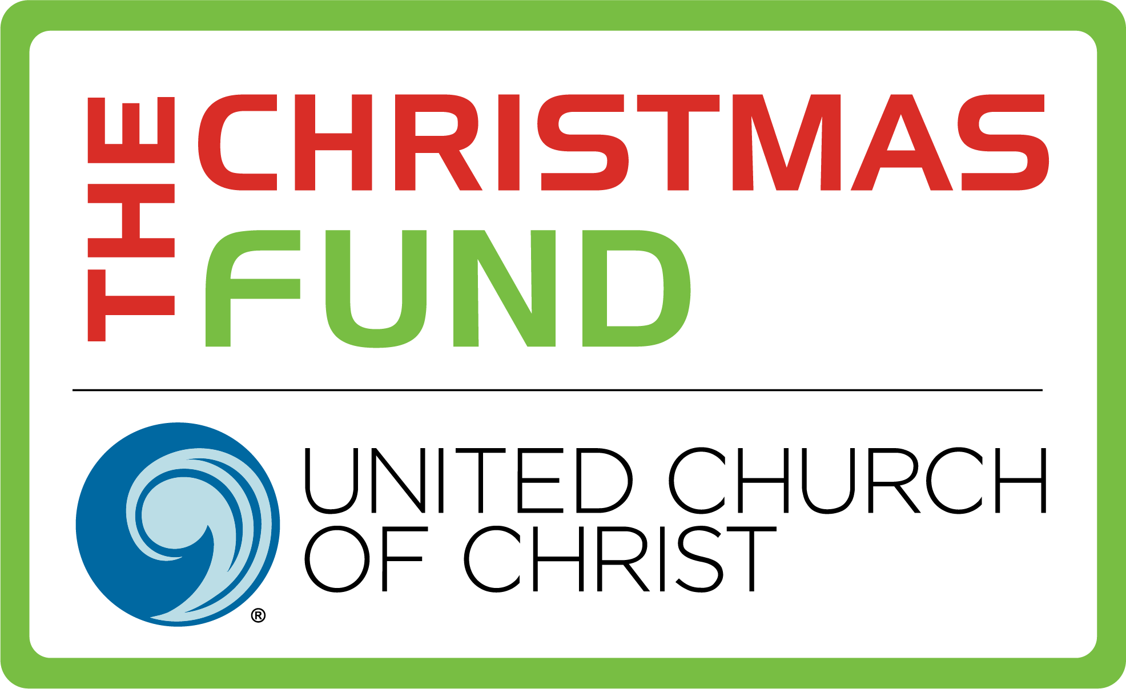
Giving to the Christmas Fund gives you an opportunity to be a part of a ministry that cares for the active and retired clergy and lay persons of the United Church of Christ.

Castile UCC Food Pantry

Thank you to all who provided food items for our Food Pantry. Please continue to look on the bulletin board in the Embling Dining Hall for tags of items needed and to help with packing groceries.

Board of Trustees News
St. Pauly’s Shed latest check was for $155.38.

What to Donate: Used clothing, shoes, belts, purses, linens, blankets, curtains, and stuffed animals.
What NOT to Donate: Furniture, electronics, household items.

Thank You’s
To Tom Reagan for cleaning out the church’s eaves troughs.

To Beverly Edwards for returning another $39.00 in pop cans.

To Jen Wallace and DeLaval of Castile for their donation of turkeys for our Food Pantry’s use.

To Chuck Klein for returning another $90.00 in Scrap Metal.

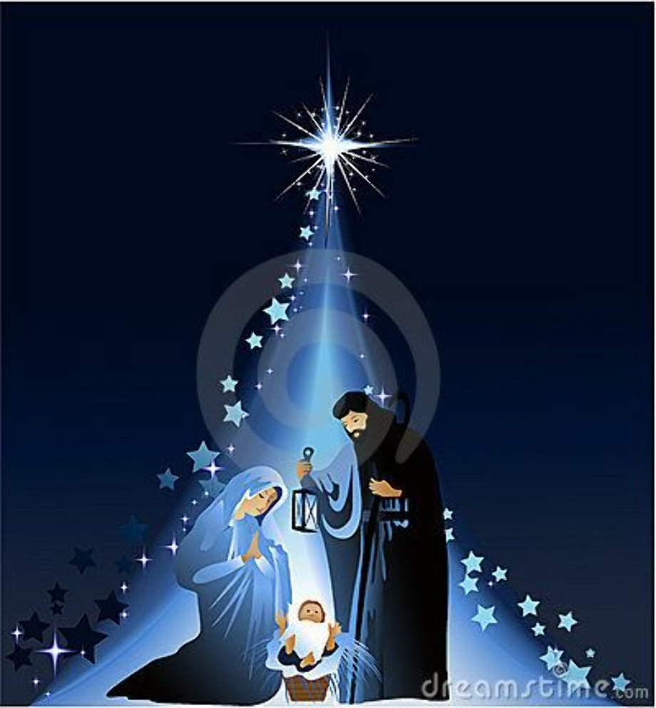

December Birthdays
3 - Steven Miller
10 - Jordan Harper
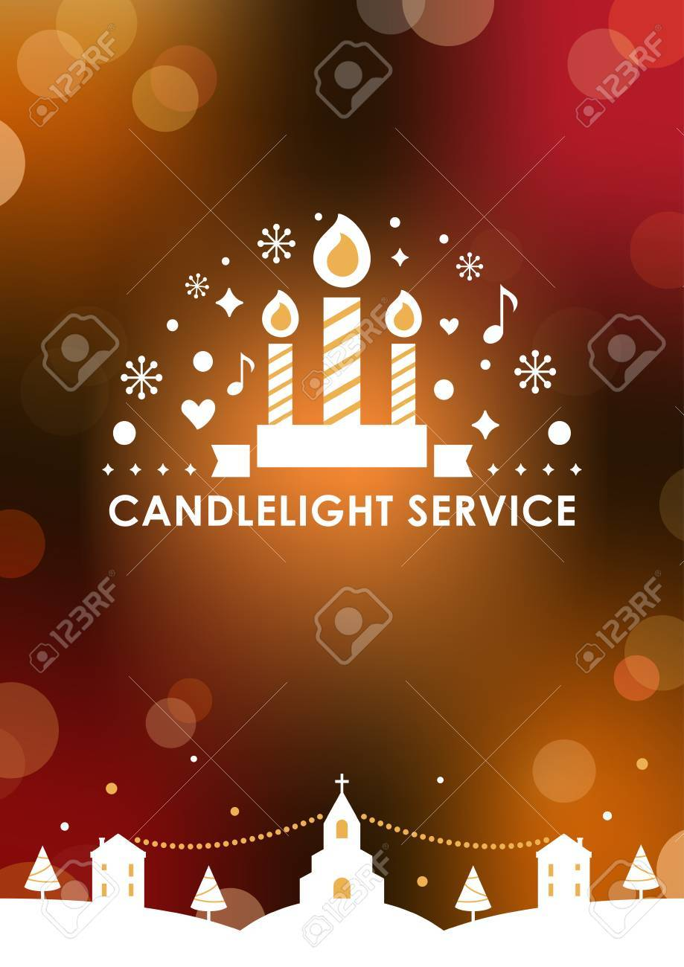
11 - Nolan Bannister
13 - Sarah Andrews
15 - Anthony Harper
18 - Steven Weaver
28 - Darla Huntz
30 - Lynn McNamara

December Anniversaries
8 - Theodore & Rose Anne Lindsey
28 - Steve & Barbara Meyer

Women’s Fellowship Our Mission Statement: “Through the belief in our Living God, our mission is to reach out and support families and individuals in need, by sharing ideas and creativity, using our time and talents to strengthen ties in the community.”

2025 Co-Chairs: Judy Goodenow & Michelle Post Co-Secretaries: Marcy VanZandt & Joan Maddison Correspondence: Carol Becker & Beth Pond Treasurer: Cindy Feroleto

Mon., December 8
11:00 AM
WOMEN’S FELLOWSHIP
Christmas Luncheon.

All women are invited for a time of fellowship.

This is a catered event. Please call the Church Office at 585-493-840 before December 1, to make a reservation.

Home Touch Newsletter
This is a monthly newsletter filled with scriptures, puzzles, Bible stories, etc. If you would like to be added to our mailing list, please contact the church.


 “Hats for the Homeless”: We are accepting donations of Hats, Scarves, Mittens, and Socks to donate to the homeless.
Please feel free to drop them off in the church dining room.

Thank you to those who have started bringing in those finished items. Many of these items will be donated to the Buffalo City Misson.

Military Personal Addresses

Lt. Col. Michael McLaughlin
7184 Sky Meadow Drive
College Grove, TN 37046

2nd Lt. Briana Miller (NEW ADDRESS)
507 Marlandwood Road
Temple, TX 76502


Page, Christopher Michael
3742 Patriot Drive
Apt. 201 Mail Box 5
Abilene, Texas 74606

SGT Nathan Scott
110 Vibbert Avenue Box 53476
Fort Moore, GA 31995

Chief Petty Officer Joshua Soble
2726 Trojan Ct.
Lenmore, CA 93245

Colonel Sara Torres
11537 Laurel Lake Square
Fairfax, VA 22030

**No address at this time, but please keep them in your thoughts and prayers.

Christopher Meyer

Heaven’s Gift
The night was dark, the world in need,
Yet God had planned a wondrous deed.
Through Mary’s arms, the Savior came,
To bear our sin, to take our shame.
No gift on earth could e’er compare,
To Christ, our hope, beyond despair.
So let our hearts in worship rise,
For Heaven’s gift that never dies.
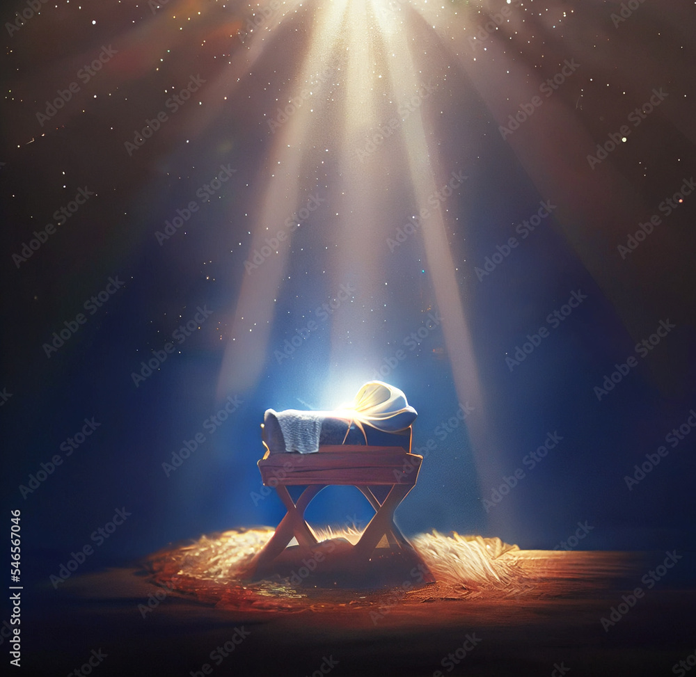

“Light Up The Night”


Friday, December 5th

beginning 5:30 PM
at the Castile Fire Hall

Village Tree Lighting

Featuring DJ Kelli Carson
“KC Sunshine Entertainment”

Hot dogs, Chips. Cider, Popcorn & Cookies!
Goodie Bags for Children
Come and wait for Santa’s arrival…

Don’t Forget: BREAKFAST with SANTA Sat., Dec. 6 9:00 – 11:00 AM at Wolf Creek Event Center

200 Years and Counting…

March 4, 2025 – First Bicentennial Comm. Meeting. Discussed Time Capsule and ways to celebrate our Bicentennial.

April 8, 2025 – Bicentennial Comm. Meeting discusses new landscaping outdoors and Bicentennial Banner

May 1, 2025 – May Breakfast decorations will include past photos of the church and activities thru the years turned into cards. Thank you to Dawn Miller for creating these amazing cards.
June 3, 2025 – Bicentennial Comm. Meeting discusses UCC Celebration Sunday. (Our First Event)

June 22, 2025 – UCC Celebration Sunday
UCC Representatives: Rev. Ryan Henderson & Joseph Robinson presented a UCCNY Certificate during Worship Service. Followed by a Cake & Punch Reception.
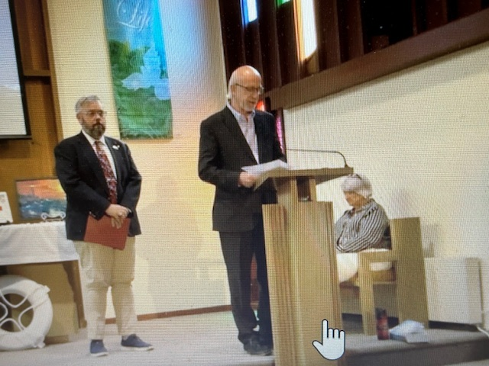

July 3, 20251 – Bicentennial Comm. Meeting to discuss items for Landscaping Dedication and other upcoming events.

September 21, 2025 – New Landscaping Dedication by Pastor Tammy Lathan on front lawn.

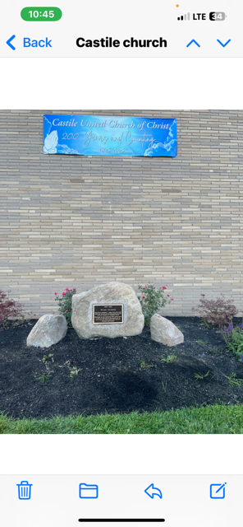
Thank you to the Van Slyke Family for donating and moving the boulder and stones used for the focal point of the design.

October 25 - Bicentennial Organ Concert
Guest Organists: A. David Hurd and John Novak. Also, performances by Castile UCC Church Choir & Handbell Choir and handbell Tree solo by J. Thomas Reagan. Refreshments served in Embling Dining Hall. Bicentennial Basket Raffle winners were announced.

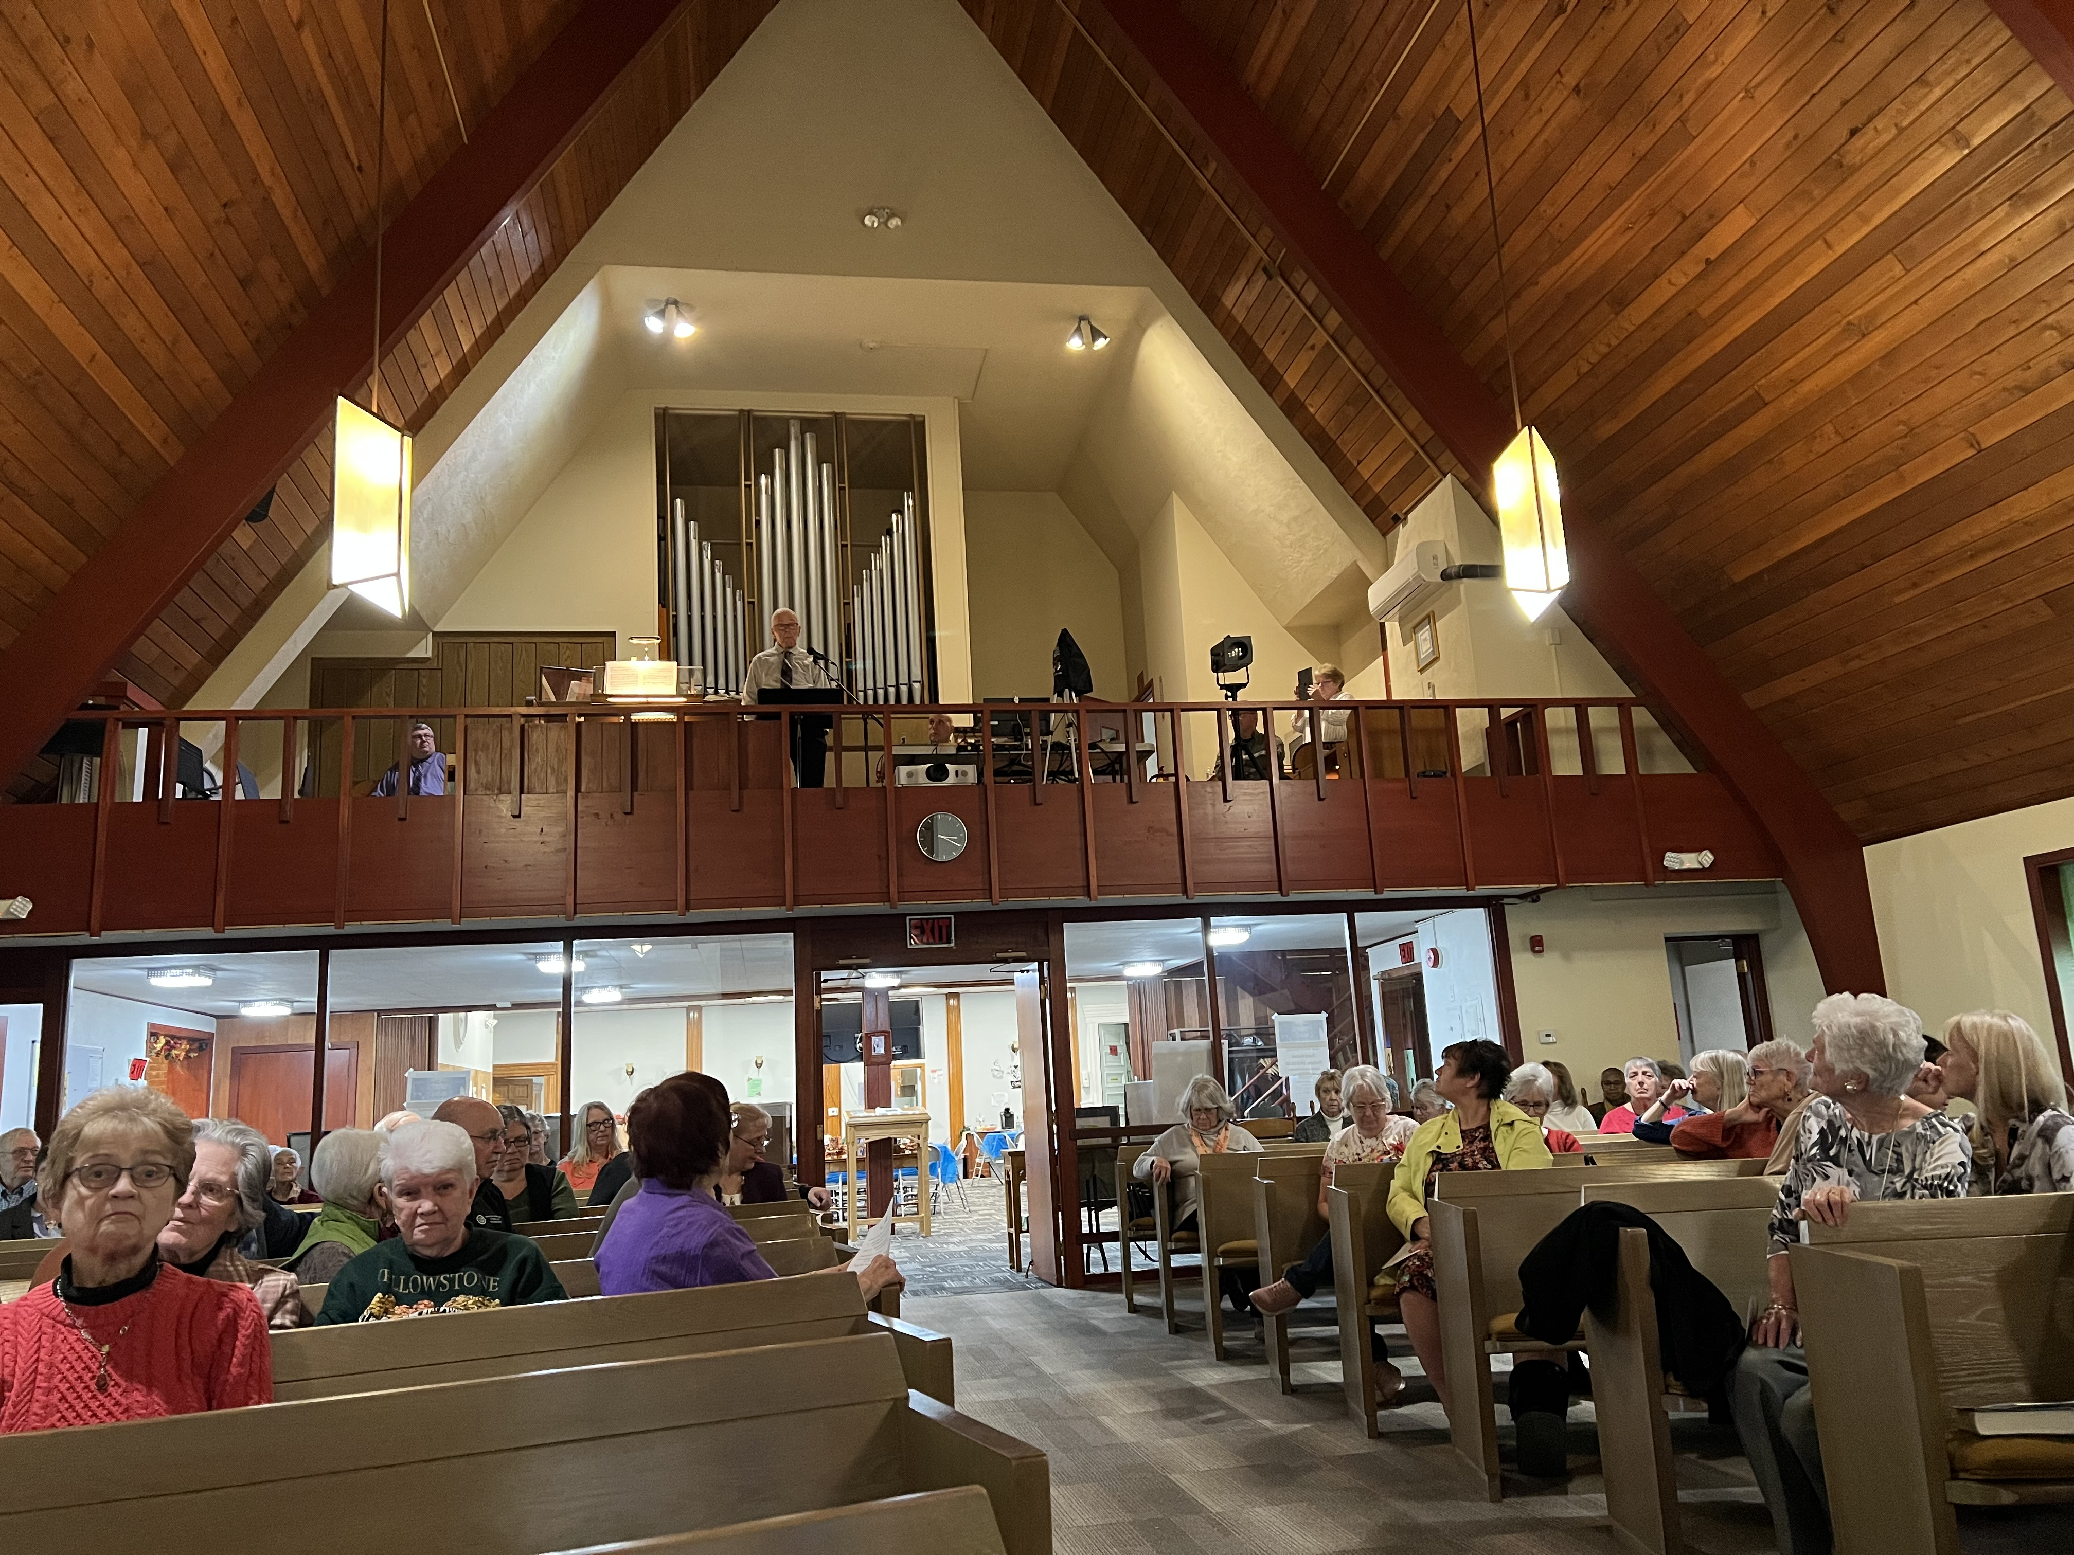

Nov. 16 – Final Bicentennial Event’
Worship Service with Recognition of Long-Term members followed by an All-Church Tureen Dinner.
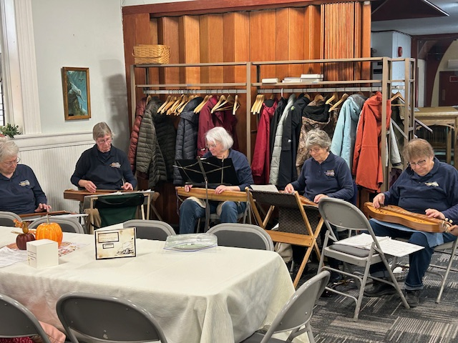
Special Music by the Genessee Valley Dulcimer Group

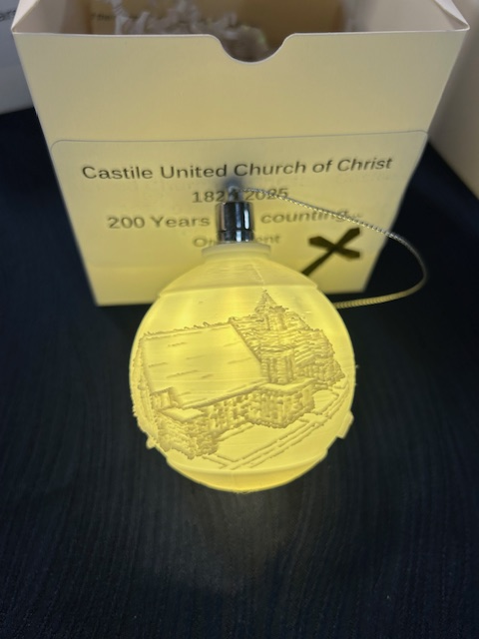
A Special Bicentennial Ornament was presented to members. Thank You to Christopher & Jen Griesbaum for designing and printing our Special 3-D Bicentennial light up ornaments.

200 Years and Counting Committee:
Beverly Edwards Rose Anne Lindsey
Linda Little Marlene Loomis
Dawn Miller Bonnie Miller
Charles Miller Beth Pond
Tom Reagan Mary Reagan

Time Capsule – Last summer, our 1963 Time Capsule was discovered when some of the outside doors were replaced.
The Original Time Capsule will be refilled as part of our Bicentennial Celebration. It will be placed back in its original space for future generations.

