Castile United Church of Christ
P.O. Box 512 Castile, NY 14427
Church Phone: 585-493-2840
Church E-Mail: Castile_UCC@yahoo.com
Pastor: Tammy Lathan
Pastor Tammy’s Cell Phone: 585-969-0695
United Flyer Editor: Marlene Loomis



March 2026 “United Flyer”

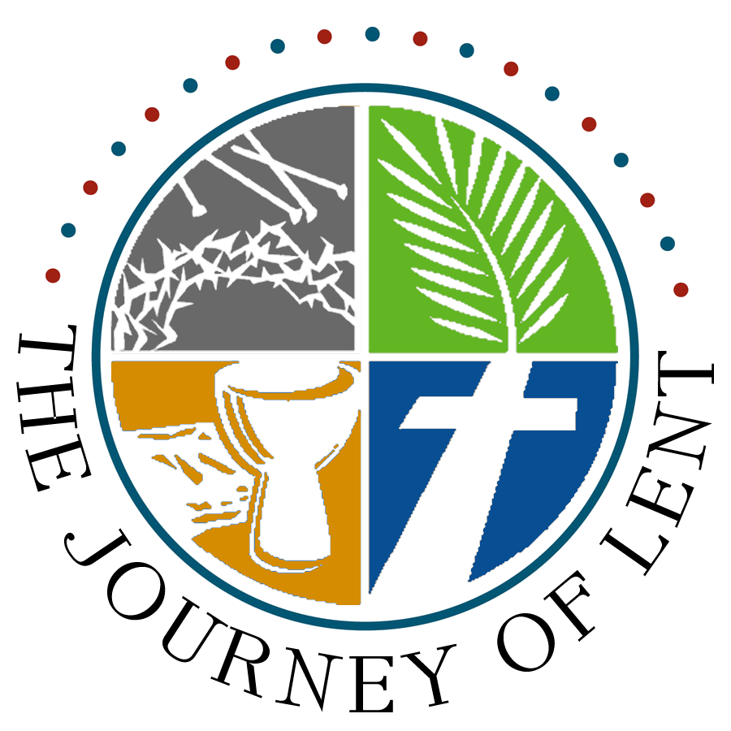

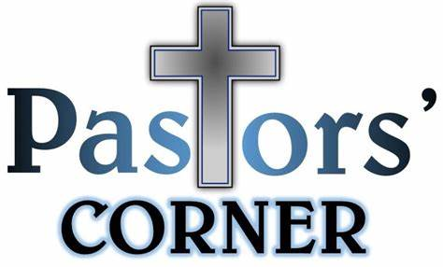

Take a Deeper Look at
St. Patrick’s Day


We in the church don't make much of St. Patrick’s Day. The March holiday conjures up images of green beer, the green river in Chicago, parades, and shamrock cookies. Fun stuff for some. Dangerous for others, as victims of binge drinking might be able to tell you if they are still with us.
Why do we celebrate this day? Who was St. Patrick? Is there any message for the church in this story? St Patrick, or Patricius as he signed his letters, was born into a Christian family in Britain. When he was 16 years old, he was captured by Irish raiders and taken to Ireland. While there, he came to the realization that Christianity was real and he converted to his family's faith.
After working as a sheep herder for a miserable six years, he heard a voice telling him to escape. He eventually found a ship waiting to take him home to Britain. He finally made it back to his family and there he decided to become a priest.
Later, he was moved to become a missionary to Ireland where he brought many to the faith, possibly by using the shamrock to explain the three persons of the Trinity.
The story of Patrick is a story of two slaves: the slave of the world and the slave of Christ. Like Joseph, he was captured as a teen and sent to serve a worldly master in a strange land. His suffering brought him to surrender to his God.
Now he desired to be captive to another master. Like Paul, he became “a bondservant of Jesus Christ.” He once served his cruel captors but broke free in order to serve the true, loving Master.
Romans 6;18 “You were made free from the power of sin. Being right with God has power over you now.” Patrick could have stayed in Britain living a comfortable life but chose to give it all up to bring the gospel to a pagan nation. And that's no blarney!

Church Directory

Pastor: Tammy Lathan
Pastor Tammy’s Winter Office Hours:
Tuesday & Thursdays: 9:00 AM - 1:00 PM
Wednesdays – By Appointment
Pastor Tammy’s Cell: (585) 969-0695
Church Phone: (585) 493-2840
Church E-mail: Castile_UCC@yahoo.com
Website: www.castileucc.com

Administrative Coord.: Marlene Loomis – 493-2968
Church Moderator: Dennis Miller – 233-8933
Bd. of Elder Chair: Cindy Feroleto – 493-2696
Bd. of Trustees Chair: Scott Chamberlain – 752-3454
Custodian: Leilani Helmer – 813-4164
Director of Music: Barbara Meyer – 322-7396
Supt. of Build/Grounds: Greg VanSlyke – 493-5874

Lenten Fireside Chats

Wednesdays at 6:00 PM on Facebook
“Lent in Plain Sight” by Jill J. Duffield

In this devotional for the season of Lent, Jill draws readers attention to ten ordinary objects that Jesus would have encountered on his way to Jerusalem.
Each week, readers encounter a new object to consider through Scripture, prayer, and reflection to open ourselves to the kingdom of God.

Facebook Live
Most of our worship services can be viewed on Castile UCC Facebook Live or you can view it anytime at your leisure for up to 30 days.

FACEBOOK Volunteers Needed:
FREE TRAINING
The Board of Elders are looking for volunteers to help with the Sunday morning FACEBOOK recording of our Worship Service. This has become such a vital outreach to people who can’t attend.

If you would be willing to help out, please contact Pastor Tammy. Thank you!

Newsletter Deadline
All newsletter articles for the “United Flyer” are due by the 15th of each month and are at the discretion of the church office. We welcome your submissions.

March Lenten Symbols

Sun. 1 – “Communion Cup
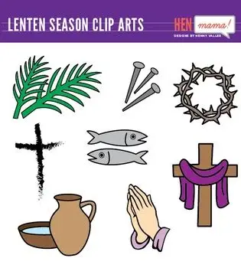
Sun. 8 – “Praying Hands”
Sun. 15 – “Sand”
Sun. 22 – “Nails”
Sun. 29 – “Palms” - Palm Sunday



Easter Lilies
*** We will not be ordering live Easter Lilies this year. There will be several artificial ones used in our decorating.

Upcoming Easter Events

Sun., March 29 – Palm Sunday

Thur., April 2 – Maundy Thursday
6:30 PM – Tureen Dinner
(Please bring a dish to pass, your own table service and a beverage.)
7:15 PM- Sanctuary Program

Sun., April 5 – Easter Sunday 10:00 AM
(In person and Facebook Live)
No Sunday School so that families
may worship together.

Sunday Brunch
Sun., March 8 Hosted by our Board of Christian Education

Christian Education News



You can also check out the weekly lessons by
logging on to Sermons4Kids Schedule:

March 1 - “Measuring God’s Love”
8 - “Women at the Well”
15 - “Jesus Heals the Blind”
22 - “Jesus Raises Lazarus from the Dead”
29 - “The King is Coming”


Missions News
Scrap Metal Mission
cast iron copper stainless steel steel brass aluminum lawn mowers electric motors old machinery power tools hand tools batteries
NO: T.V.’s, computers, air conditioners, freezer, refrigerators (nothing with Freon in it.)
Contact Chuck Klein at 567-8204 for pick up.

One Great Hour of Sharing – March 15

OGHS helps spread God’s message of love and hope to people in crisis. The UCC works with international partners to provide sources of clean water, food, education and health care, resettlement for refugees, and emergency relief. It also supports domestic and international ministries for disaster preparedness and response.



Castile UCC Food Pantry

Thank you to all who provided food items for our Food Pantry. Please continue to look on the bulletin board in the Embling Dining Hall for tags of items needed and to help with packing groceries.

Board of Trustees News
Church Rental Fees

Member Fee: $50.00
Non-Members Fee: $100.00
This includes use of the church dining room, kitchen facilities, handicap lift and bathroom.
NOTE: If you rent the church, you will need to take your trash home with you. Thank you!
St. Pauly’s Shed

What to Donate: Used clothing, shoes, belts, purses, linens, blankets, curtains, and stuffed animals.
What NOT to Donate: Furniture, electronics, household items.

St. Pauly’s Shed latest check was for $122.94.

Congratulations
2026 Winner Independent Press Award

Jacob R. Klein
Glory Spirit: Apostles Carrying the Story

Jacob R. Klein, the author of Stories of the Old Testament, Stories of the Old Testament: Savior Needed, and King of Kings, Rebel of Rebels: The Savior's Story, is back with the story of the apostles in the book of Acts, which happens after their master Jesus's resurrection.

You will see the waiting and experiences the apostles went through before being empowered by the Holy Spirit, the adversities they had to go through in the early stages of the church, and the fortitude Stephen showed just before his faith in Jesus would cost him his life.

Thank You’s

To EVERYONE who donated items for our Cabin Fever Dinner & Basket Raffle.
To Fran Priestly for knitting and donating 13 baby hats.

Dulcimer Players Wanted
The Genesee Valley Mountain Dulcimer Club is now meeting monthly on the 2nd & 4th Monday of each month from 1:00 to 3:00 PM.
We welcome all levels of players and want to be players, or just listeners to stop by.

If you would like more information,contact Sue Ferris at 493-2717.

March Birthdays

1 - Jeremy VanEpps
7 - Kristi Weaver
8 - Cheryl Fagan

10 - Alexander McLaughlin
10 - Jeffery Mattingly
10 - Christine Broughton
20 - R.J. Donlon-Bergeron
24 - Connie VanSlyke
27 - Naomi Bellamy
27 - Kenneth Hance
30 - Paeton Ann Feroleto 1st Birthday!!

Parables of the Bible

Parables Read from Multiple Perspectives

By Karen Austin

The Prodigal Son (Luke 15: 11-32)

When I was growing up, I would look at the Parable of the Prodigal Son from the viewpoint of the two sons — the one who rejected his heritage, lived for pleasure, and then finally became penitent after he lost everything. I also would view myself as the brother who was angry that the prodigal was forgiven.
The elder son explained his anger this way: “Lo, these many years do I serve thee, neither transgressed I at any time thy commandment: and yet thou never gavest me a kid, that I might make merry with my friends” (Luke 15:29).
This exchange illustrated the nature of forgiveness: we should not keep a ledger regarding other people’s infractions and their rewards. Jesus instructs us throughout the New Testament to show charity towards all. It is God’s place to stand in judgement.
I can also imagine myself as characters that are on the fringes of this parable: the drinking buddies, the inn keepers, — any person who took advantage of the prodigal son by promoting his vice and capitalizing on his recklessness.
How do I treat people who are vulnerable? Do I support them in vice? Or do I invite people to virtue? If someone is full of sorrow, anger, and despair, do I egg them on? Do I participate in gossip? Or do I behave like the other set of fringe characters? Am I gracious with those who have had a rough past, knowing that we all sin and fall short of the glory of God (Romans 3:23)? Can I choose more often to make a feast, provide music, and dance to celebrate those who return to fellowship? I can also do more to thank my fellow

saints who celebrate me when I return (repent) to fellowship, even if I only metaphorically left my spiritual home.
I am sure there are more ways to consider this parable for spiritual meanings. It is rich with possibilities and deserves to be reviewed regularly for, given its depth, nuance, and complexity.


Women’s Fellowship Our Mission Statement: “Through the belief in our Living God, our mission is to reach out and support families and individuals in need, by sharing ideas and creativity, using our time and talents to strengthen ties in the community.”
2026 Chairperson: Michelle Post Co-Secretaries: Marcy VanZandt & Joan Maddison Correspondence: Carol Becker & Beth Pond Treasurer: Cindy Feroleto
Home Touch Newsletter

This is a monthly newsletter filled with puzzles, scriptures, Bible stories, etc.
If you would like to be added to our mailing list, please contact the church.

Cabin Fever Dinner
Sat., February 28
4:00 – 6:00 PM

Let’s Go Camping…


- Hot Dogs
- Hamburgers
- Campfire Potatoes
- Cowboy Beans
- Coleslaw
- S’more Brownies or “Decorate Your Own” Campfire Cupcakes
- Beverages

FREE WILL OFFERING

Basket & QUEEN Size Quilt Raffle
to benefit Castile UCC Women’s Fellowship Outreaches

Quilt Tickets are $5.00 each or 3/$10.00

Military Personal Addresses

Lt. Col. Michael McLaughlin
7184 Sky Meadow Drive
College Grove, TN 37046

Page, Christopher Michael
3742 Patriot Drive
Apt. 201 Mail Box 5
Abilene, Texas 74606

2nd Lt. Briana Miller (NEW)
507 Marlandwood Rd

Apt. 1801
Temple, Texas 76502

SGT Nathan Scott
110 Vibbert Avenue Box 53476
Fort Moore, GA 31995

Chief Petty Officer Joshua Soble
2726 Trojan Ct.
Lenmore, CA 93245

Colonel Sara Torres
11537 Laurel Lake Square
Fairfax, VA 22030

**No address at this time, but please keep them in your thoughts and prayers.

Christopher Meyer


Special Congregational Meeting
February 15, 2026
The meeting was called to order by Moderator Dennis Miller at 11:00 AM. There was an opening prayer by Pastor Tammy Lathan.
The purpose of the meeting is to form a Pastoral Search Committee with representation from the following Church Committees and Groups.
The Search Committee was formed with the following volunteers:
Board of Elders: Cindy Feroleto
Board of Trustees: Scott Chamberlain
Board of Christian Education: Julia Foote
Missions Committee: Bonnie Miller
Stewardship Committee: Brooke VanEpps
Music Committee: Linda Little
Women’s Fellowship: Michelle Post
Marlene Loomis will serve as an ex-officio member with no voting rights. She will be the contact person between the UCC and our church.
Motion was made by Barb Meyer, seconded by Tom Scott to approve this Pastoral Search Committee as formed. Motion was carried.
Motion was made by Larry Rogers, second by Gary Whitmore to adjourn. Motion was carried.
Meeting adjourned at 11:05 am with the Lord’s Prayer.
Respectfully submitted,
Cindy Feroleto, Church Clerk

