Castile United Church of Christ
P.O. Box 512 Castile, NY 14427
Church Phone: 585-493-2840
Church E-Mail: Castile_UCC@yahoo.com
Pastor: Tammy Lathan
Pastor Tammy’s Cell Phone: 585-969-0695
United Flyer Editor: Marlene Loomis


October 2025 “United Flyer”

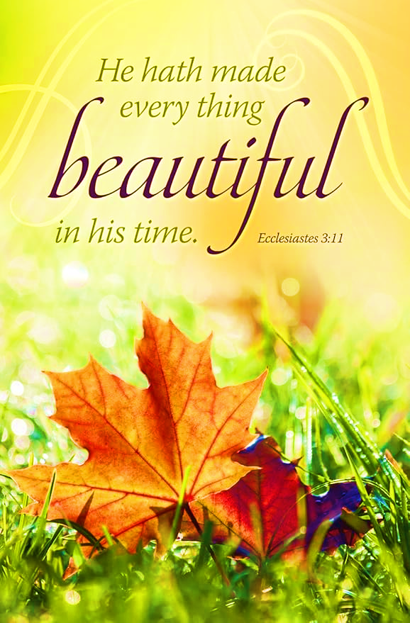
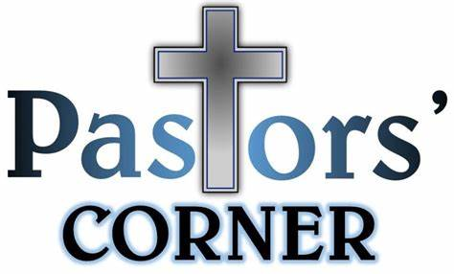

How We Disciple to Others
Yes, the title and content may sound familiar as this is a condensed version of the message I shared on July 5 and I thought it might be worth repeating as October is Worldwide Communion.
Contributed by Tim Smith. Scripture: Luke 10:1-7
Communion can be a perplexing experience for us as believers, but then, maybe even more so for visitors. Randy tells the story of a friend who attended worship for the very first time and it was a Communion Sunday. “People were called to receive the elements, and my friend thought it was pretty cool that we were taking a break in the service for a snack. Imagine the shock when my friend rip off a handful of bread and drank four cups of juice!”
From the outside looking in, Communion can be a bit perplexing. People eating a piece of bread with grape juice and proclaiming they are eating the body and blood of Christ.
But there is a reason we have gathered around this table for nearly 2,000 years. Holy Communion is a sacrament or initiation. The church chose the word sacrament because communion is a ritual that is at the same time a spiritual and physical act.
Those who take communion receive a new spiritual status and new duties before God. Communion is one of the sacraments in the UCC, the other is Baptism. A sacrament is decided by a simple question, “Did Jesus do it?” Communion was given to us by Jesus during the Passover celebration which was his last meal with his disciples. So, what is communion?
It is participation in Christ’s death. 1 Corin. 11:26 “For whenever you eat this bread and drink this cup, you proclaim the Lord’s death until he comes.” Communion isn’t just something we do in memory of Jesus, but, in some way, by receiving
communion, we are caught up in the work of Jesus on the cross; right now, in the present moment. When we take communion, we are responding to the call of Jesus to die to ourselves and to sin.
We experience the presence of Christ Matthew 18:20 Jesus said, “For where two or three gather in my name, there am I with them.” These ordinary everyday elements become vessels for the very real presence of Jesus and his sacrifice on the cross. The Holy Spirit is always with us, but the mystery of communion is Jesus meeting us in a physical and visible way. When we come to the table, the very presence of Jesus is there.
We receive God’s grace. John 1:16-17 For from his fullness we have all received, grace upon grace. For the law was given through Moses; grace and truth came through Jesus Christ. When we take this bread and drink this cup, we are receiving the benefits offered to us through Christ’s sacrificial death, God’s grace and his forgiveness.
Communion grants us an opportunity to encounter the grace of God offered through Jesus in a very real, physical way. Grace is God’s gift of love and forgiveness. It is given freely; it cannot be earned. Grace blesses us when we do not deserve it. Grace meets us in the middle of our mess and offers us forgiveness and restoration. It empowers us to address our failure, and it takes away the power and control that fear has over us.
When we come to this table we are admitting we are broken and therefore we make ourselves ready to receive God’s grace. Communion grounds us in the truth that God loves us just as we are, but God also loves us enough to not leave us that way. Communion is our opportunity to have a fresh encounter with God, to be in his presence, to be reminded we are loved, accepted and made new.
Jesus is the only one who can make us new. If you have never said yes to the grace of God offered to us in Jesus, then now is your opportunity. God loves you and accepts you as you are, no matter what you have done. God’s grace is right here waiting for you. Thanks be to God. Amen.

Church Directory
Pastor: Tammy Lathan
Pastor Tammy’s Office Hours:
Tuesday & Thursdays: 8:00 AM - 12:00 PM
Wednesdays – By Appointment
Pastor Tammy’s Cell: (585) 969-0695
Church Phone: (585) 493-2840
Church E-mail: Castile_UCC@yahoo.com
Website: www.castileucc.com

Administrative Coord.: Marlene Loomis – 493-2968
Church Moderator: Dennis Miller – 233-8933
Bd. of Elder Chair: Cindy Feroleto – 493-2696
Bd. of Trustees Chair: Ron Lathan – 703-5286
Custodian: Leilani Helmer - 813-4164
Director of Music: Barbara Meyer - 322-7396
Supt. of Build/Grounds: Greg VanSlyke - 493-5874

Newsletter Deadline
All newsletter articles for the “United Flyer” are due by the 15th of each month and are at the discretion of the church office. We welcome your submissions.


Preaching Schedule

Sun., October 5- Bonnie Miller – Guest Speaker Neighbors in Need Sunday
Sun., October 12- Communion & Brunch Sunday
Sun., October 19- Church Council Sunday
Sun., October 26- 20th Sunday after Pentecost

Clerk’s Records
Deaths:
Robert Scott Jr. (Betsy DeGroff’s brother) died on August 24, 2025.
Brunches
Sun., October 12 - Provided by the Nominating & Stewardship Committees.


Church Council Meeting
Our next Church Council meeting will be held on Sun., October 19 at 11:00 AM.
This is a very important Council Meeting as we will be voting on the 2026 Budget.
Please have your reports ready by Wed., October 15 to be copied, as this is a great time saver.

Facebook Volunteers Needed:

FREE TRAINING
If you are able to help out with recording our Sunday Morning worship, please contact Pastor Tammy to join our Sunday Morning Facebook Team.

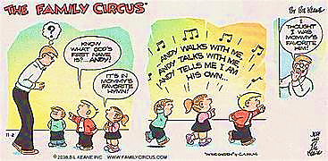
Christian Education News

Sunday School has started back up. If you would like to follow along with the weekly lessons, You can check them out on www.Sermons4Kids.com

October 5- “A Mustard Seed Faith”
12- “The Thankful Leper”
19- “Pray and Don’t Give Up”
26- “The Pharisee and the Tax Collector”
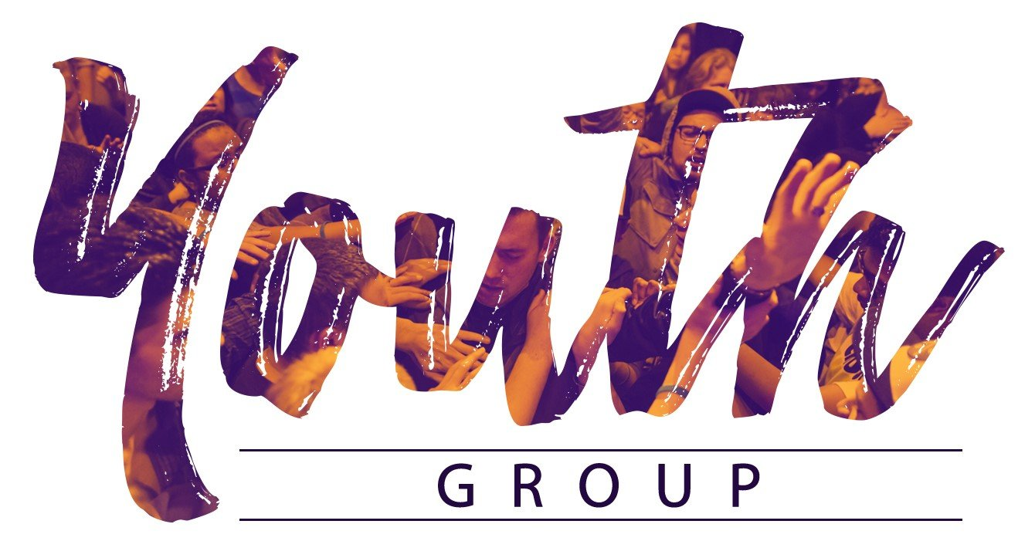

Calling all Youth.
New Youth Group is forming for YOU!

In the next several weeks you will be receiving a letter informing you of the New Youth Group to be held at the Castile United Church of Christ.
Youth Group Leaders are Jenifer Wallace, Sandy Graham and Kristi Weaver.
They are currently working on scheduling Fall Activities and it is open to Youth in grades 8 – 12.

Stay Tuned for more details!!!

October Altar Flowers
5- Connie VanSlyke
12- Kathy Spencer
19- Betsy DeGroff
26- Colleen Bean
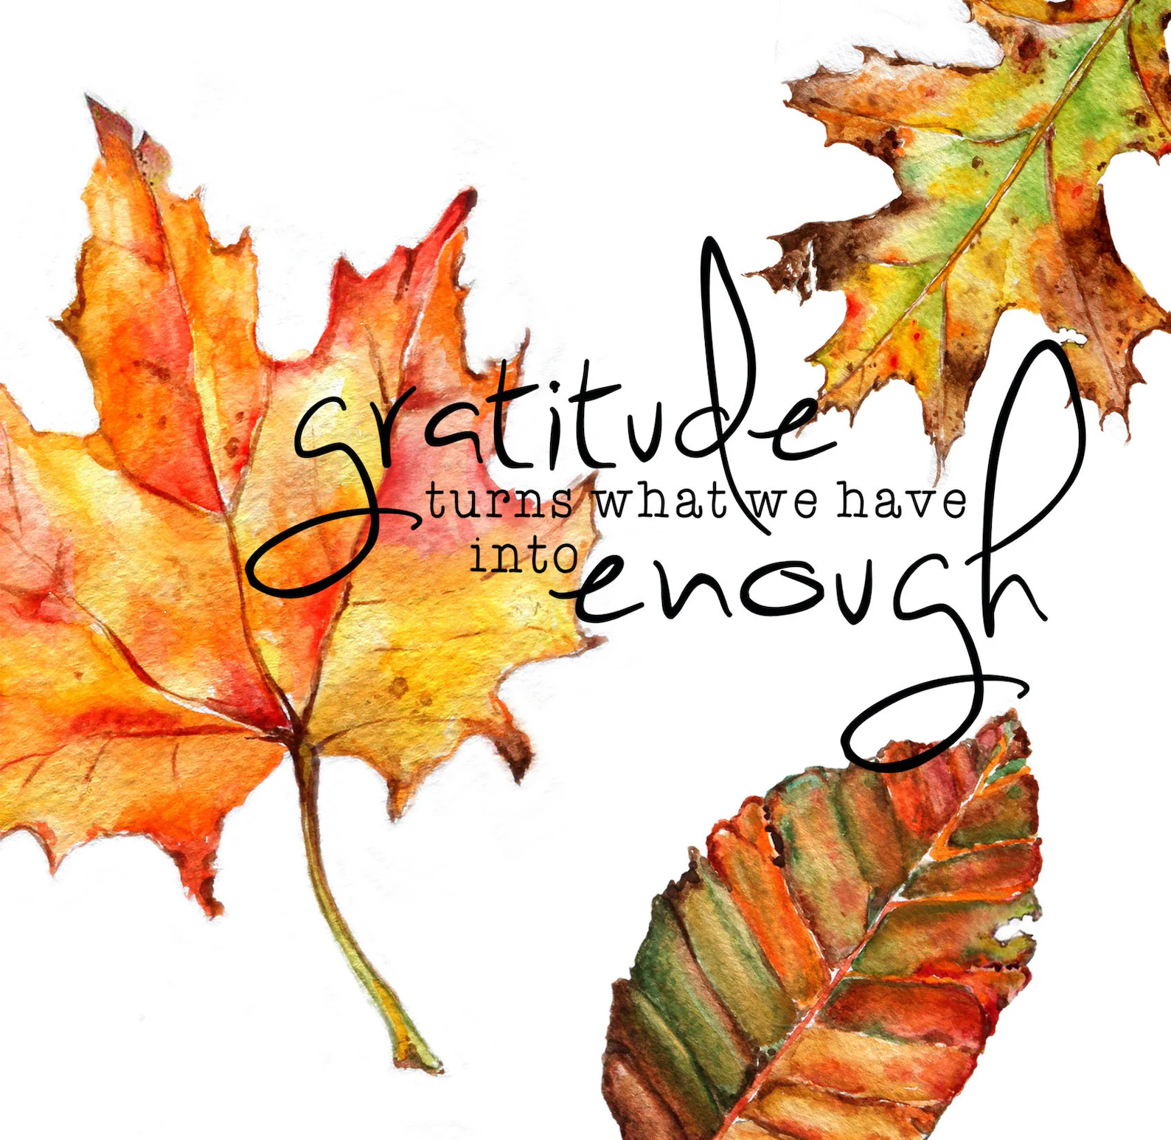
Church Rental Fees

Wedding Showers? Holiday Parties?
We would like to remind you that the Embling Dining Hall is available for rent.
Member fee is $50.00 and non-members $100.00. This includes use of the church dining room, kitchen, several refrigerators for food, 10 burner stove with two large ovens, and Bunn coffee maker.
NOTE: As we no longer have trash service at the church. You will need to take your trash home with you. Thank you!

Castile UCC Food Pantry

The Food Pantry is OPEN to any resident in the Town of Castile and may be visited monthly.

Please contact 585-493-2840 to make an appointment. The first and second Tuesdays and Thursdays of each month are pick up days.

Thank you to all of our Food Pantry Staff.

Missions News
Scrap Metal Mission
cast iron copper stainless steel steel brass aluminum lawn mowers electric motors old machinery power tools hand tools batteries
NO: T.V.’s, computers, air conditioners, freezer, refrigerators (nothing with Freon in it.)
Contact Chuck Klein at 567-8204 for pick up.

Our latest check for scrap metal was $25.00. Thank you to Chuck Klein for organizing this beneficial mission.

2025 Neighbors in Need
October 5 Offering

The 2025 Neighbors in Need Theme is:
“Mental Health is a Universal Human Right”

A just world for all is a world where the human
rights and well-being of people with mental health challenges are respected no matter who you are or where you are in life’s mental journey.
Please join us in promoting this year’s NIN “Mental Health is a Universal Human Right” campaign.

SERRV

Since 1949, SERRV has been helping to fight global poverty through fair and ethical trade.

One of the first fair trade organizations in the world, SERRV International, began its mission in 1949 after World War II by helping displaced European refugees trade their handcrafts for income. Since then, we've extended our reach to countries worldwide, supporting over 8,000 artisans and farmers annually by selling their beautiful handcrafts.

SERRV items will be available for your holiday shopping most Sundays during October, November and December. New items will be ordered soon, when the new inventory for ordering is available.

This is a great way to support Worldwide Missions!
Board of Trustees News
St. Pauly’s Shed latest check was for $168.63.
What to Donate: Used clothing, shoes, belts, purses, linens, blankets, curtains, and stuffed animals.

Beginnings
“Begin today. Declare out loud to the universe that you are willing to let go of struggle and eager to learn through joy.” . - Sarah Ban Breathnach
“It’s humbling to start fresh. It takes a lot of courage. But it can be reinvigorating. You just have to put your ego on a shelf and tell it to be quiet.” . - Jennifer Ritchie Payette
“A year from now you may wish you had started today.” - Karen Lamb
“It’s a wise man who understands that every day is a new beginning, because boy, how many mistakes do you make in a day? You can’t turn the clock back, so you have to look ahead.” . - Mel Gibson
submitted by Greg VanSlyke

October Birthdays
1 - Angelo Feroleto
3 - Charlie Miller
4 - Edwin Gunn
5 - Carol Becker

6 - Rose Ann Lindsey
8 - Christopher VanZandt
9 - Kathy Spencer
14 - Mark Everingham
17 - Darcie Ikeler
19 - Kathy Pitts
28 - Donald Lockwood
29 - Sheri Brandes
30 - Patrick Feroleto
31 - Kelcy Brandes

October Anniversaries
18 - Quinn & Barbara Bellamy
21 - Frank & Colleen Bean

Thank You’s
To Jim Loomis for organizing the repair to one of the glass panels panes in the Baker Entry door. Also, to Robb’s Glass for doing the repair.

To Greg & Connie VanSlyke for seeding and watering the new lawn areas.

To Mark Barber for continuing to mow the church lawn.

To Scott Chamberlain & Michelle Post for purchasing and picking up our new parking lot barriers.

To Beverly Edwards for returning another $23.00 in pop cans.

Please remember: Pop cans and bottles may be returned to the Warsaw Redemption Center in the name of Castile UCC. They send a check to the church.
200 Years and Counting… 1825-2025

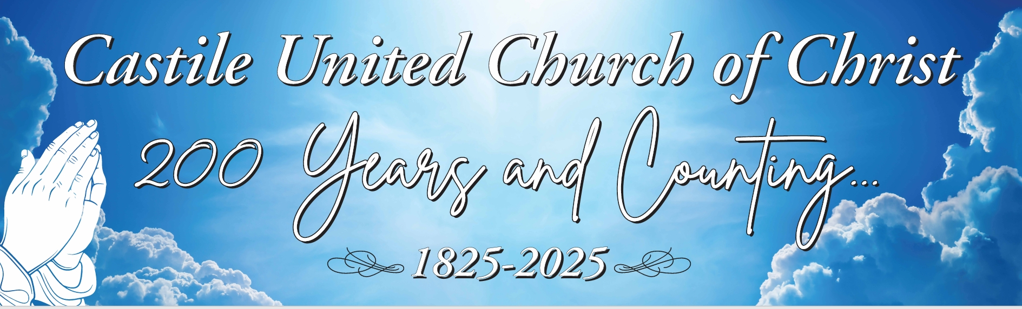

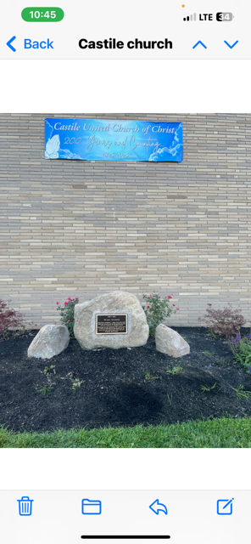
Thank you to Gibney Monuments in Perry, NY for the amazing plaque.

NEXT Bicentennial Event -
Fall Music Concert October 25 at 3:00 PM -
For many years our Church has had the reputation of being a Church filled with music. As we celebrate our Bicentennial year, it seems appropriate that we offer a musical opportunity for our Church and surrounding community.

On October 25th, in coordination with the Bicentennial Committee and Music Committee, our church will present an afternoon of music featuring A. David Hurd at the organ, the Church Choir under the direction of Barbara Myer and the Bell Choir under the direction of Tom Reagan.

David Hurd is no stranger to the church, having been one of the former Church Organists and Choir Directors. He brings his years of experience to us as he talks about the capabilities of our organ and demonstrates some of these. He will also offer several organ selections for our listening enjoyment.

Our Church Choir looks forward to presenting several anthems. We are fortunate to sing every Sunday from September through June. Barb has an uncanny way of presenting just the right anthem for each Sunday. At the piano as our accompanist, is a long-time Choir member Lisa Gunn. Lisa grew up in our church and is well known to us for her talent, kindness and commitment.

Tom Reagan, a local retired physician, has directed our Bell Choir for many years. This choir performs frequently during our worship services. Watching them is entertaining in itself and they demonstrate many techniques that Tom has taught them. Our church and community is fortunate to have the opportunity to attend such a concert of enjoyable music. This also gives our Church the moment to celebrate our Bicentennial year with music that will Praise the Lord.

Bonnie Miller

FINAL BICENTENNIAL EVENT: November – All Church Harvest Dinner
Sunday, Nov. 16, 2025, following Church Service. Please bring a dish to pass and your own table service. We will also present the congregation with a Special 3D printed Bicentennial Ornament.
ALSO ON DISPLAY:
Items that will be included in the 2025 Time Capsule!
Women’s Fellowship Our Mission Statement: “Through the belief in our Living God, our mission is to reach out and support families and individuals in need, by sharing ideas and creativity, using our time and talents to strengthen ties in the community.”
2025 Co-Chairs: Judy Goodenow & Michelle Post Co-Secretaries: Marcy VanZandt & Joan Maddison Correspondence: Carol Becker & Beth Pond Treasurer: Cindy Feroleto
Home Touch Newsletter
This is a monthly newsletter filled with scriptures, puzzles, Bible stories, etc. If you would like to be added to our mailing list, please contact the church.

Please NOTE:
October Women’s Fellowship meeting has been moved to
Monday, October 6 due to Colombus Day. All women are welcome to join us for Fellowship.
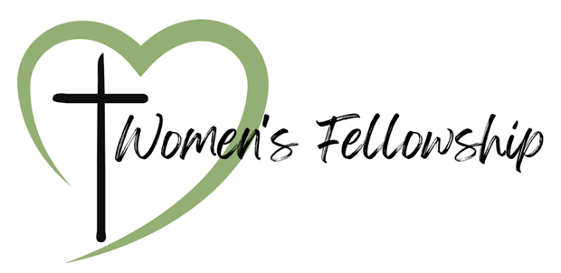
Women’s Prayer Brunch

Host Church: Castile UCC

Theme: ‘Prayer is the Key’

“And all things, whatsoever ye shall ask in prayer, believing, ye shall receive.” ~ Matthew 21:22

Sat., October 18 – 10:00 AM

Speaker: Tammy Lathan

Military Personal Addresses

Lt. Col. Michael McLaughlin
7184 Sky Meadow Drive
College Grove, TN 37046

Page, Christopher Michael
3742 Patriot Drive Apt. 201
Mail Box 5
Abilene, Texas 74606


SGT Nathan Scott
110 Vibbert Avenue
Box 53476
Fort Moore, GA 31995

Chief Petty Officer Joshua Soble
2726 Trojan Ct.
Lenmore, CA 93245

Colonel Sara Torres
11537 Laurel Lake Square
Fairfax, VA 22030

**No address at this time, but please keep them in your thoughts and prayers.

Christopher Meyer Briana Miller

