Castile United Church of Christ
P.O. Box 512 Castile, NY 14427
Church Phone: 585-493-2840
Church E-Mail: Castile_UCC@yahoo.com
Pastor: Tammy Lathan
Tammy’s Cell Phone: 585-969-0695
United Flyer Editor: Marlene Loomis

September 2025 “United Flyer”

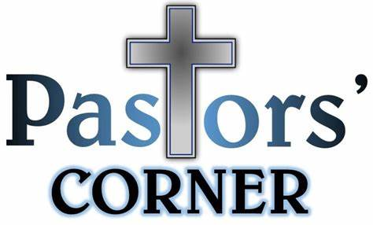

A REVIVAL of POLITENESS
The following is a great little story or illustration from Mark Batterson's book entitled, “Please, Sorry, Thanks” –
For the love of Emily Post, we need a revival of politeness, and it starts with please. “It sets the tone for whatever follows and is one of the most universal manners.” (The Magic Words – The Emily Post Institute, Inc.)

Nothing primes the pump like please, especially if you put a pretty in front of it. How does it work? “It changes a command into a request.” (The Magic Words – The Emily Post Institute, Inc.)

News flash:
NO ONE WANTS TO BE TOLD WHAT TO DO

When Christian Herter was governor of Massachusetts, he stopped by a church barbecue after a long day on the campaign trail. As he made his way down the serving line, he asked whether he could have a second piece of chicken. The woman serving the chicken said, “Sorry. Only one to a customer.”
Governor Herter was a humble man, but he was also hungry. “Do you know who I am? I'm the governor of the state.” Without skipping a beat, the woman replied, “Do you know who I am? I'm the lady in charge of the chicken. Move along, mister!
Demands come across as entitled, governor or not. A simple, please, levels the playing field. It will get you further than your title, your rank or your credentials. Authenticity trumps authority, like a royal flush.
The word please demonstrates a posture of humility, and no one did it better than Jesus. “Let this mind be in you which was also in Christ Jesus:
“Who, existing in the form of God, did not consider equality with God something to be grasped, but emptied Himself, taking the form of a servant.”
~ Philippians 2:5

Church Directory
Pastor: Tammy Lathan
Pastor Tammy’s Office Hours:
Tuesday & Thursdays: 8:00 AM - 12:00 PM
Wednesdays – By Appointment
Pastor Tammy’s Cell: (585) 969-0695
Church Phone: (585) 493-2840
Church E-mail: Castile_UCC@yahoo.com
Website: www.castileucc.com

Administrative Coord.: Marlene Loomis – 493-2968
Church Moderator: Dennis Miller – 233-8933
Bd. of Elder Chair: Cindy Feroleto – 493-2696
Bd. of Trustees Chair: Ron Lathan – 703-5286
Custodian: Leilani Helmer - 813-4164
Director of Music: Barbara Meyer - 322-7396
Supt. of Build/Grounds: Greg VanSlyke - 493-5874

Newsletter Deadline
All newsletter articles for the “United Flyer” are due by the 15th of each month and are at the discretion of the church office. We welcome your submissions.

Clerk’s Records
Weddings
Nathan Scott & Grieyzel on July 8
Nathan is the son of Tom & Bonnie Scott

Deaths:

Christian Education News


You can also check out the weekly lessons by logging on to Sermons4Kids Schedule:

September 7- “Counting the Cost”
14- “The Lost Sheep”
21- “The Dishonest Manager”
28- “The Rich Man and Lazarus”

Sunday School Classes resume on Sun., September 21, 2025.
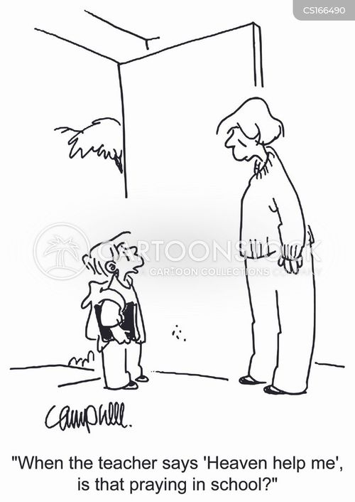

September Altar Flowers
7- Bonnie Scott
14- Castile Village Park Service - Brooke VanEpps
21- Marcy VanZandt
28- Lisa Gunn

Church Rental Fees

Member Fee: $50.00
Non-Members Fee: $100.00
This includes use of the church dining room, kitchen facilities, handicap lift and bathroom.
NOTE: We no longer have trash service at the church. If you rent the church, you will need to take your trash home with you. Thank you!
Book your event early for the best choices!
Brunches
Sun. September 14 at the Castile Village Park
Brunch served by the Castile UCC Bd. of Trustees

Missions News
Scrap Metal Mission
cast iron copper stainless steel steel brass aluminum lawn mowers electric motors old machinery power tools hand tools batteries
NO: T.V.’s, computers, air conditioners, freezer, refrigerators (nothing with Freon in it.)
Contact Chuck Klein at 567-8204 for pick up.

Update on Texas Flood Victims Offering:

Castile UCC Food Pantry
The Food Pantry is OPEN to any resident in the Town of Castile and may be visited monthly.

Please contact 585-493-2840 to set up an appointment. The first and second Tuesdays and Thursdays are pick up days.

See the bulletin board in the Embling Dining Hall for a list of items needed for the Food Pantry.

Neighbors in Need

Board of Trustees News
St. Pauly’s Shed latest check was for $
What to Donate: Used clothing, shoes, belts, purses, linens, blankets, curtains, and stuffed animals.

The paving of our church parking lot is scheduled for the end of JULY.
Stay tuned for more details.


Thank you’s
September Birthdays
1 - Braydon Miller
1 - Keaton King
3 - Charles Klein
6 - Timothy McMullen
6 - Kelly McLaughlin
10 - Bonita Stenshorn
16 - Marcia McMullen
18 - James Loomis
18 - Bonnie Miller
18 - Sandra Sickles
21 - Daniel Brandes
21 - Andrew Klein
26 - Melissa Dake
26 - Mark Miller

September Anniversaries
7- Paul & Abbey Scott
9 - Mark & Kathleen Donlon Miller
27 - Jim & Linda Little
29 - Chris & Lynn McNamara

Beginnings
- “Arriving at one goal is the starting point to another.” —John Dewey
- “Every day is a chance to begin again. Don’t focus on the failures of yesterday, start today with positive thoughts and expectations.” —Catherine Pulsifer
- “It’s a new dawn, it’s a new day, it’s a new life for me, and I’m feeling good.” —Nina Simone
- “Each new day is a blank page in the diary of your life. The secret of success is in turning that diary into the best story you possibly can.” —Douglas Pagels
- “Do not wait until the conditions are perfect to begin. Beginning makes the conditions perfect.” . —Alan Cohen
submitted by Greg VanSlyke
200 Years and Counting… 1825-2025

The Bicentennial Committee would like to invite you to share about WHAT the church has meant to you over the years... (You do not have to include your name.) It is our hope to print these into a booklet to pass out at our final event in November.

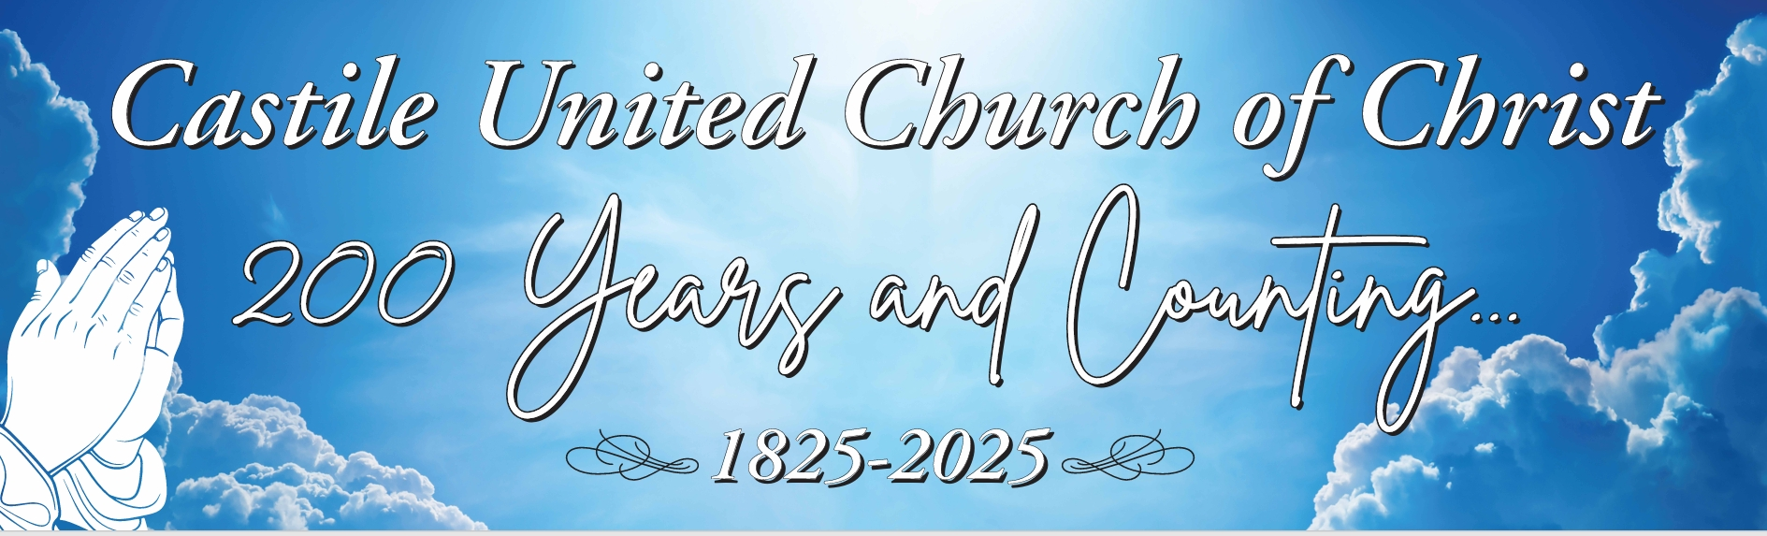
UPCOMING Bicentennial Events

September – Dedication of the New Landscaping

October - Fall Music Concert
Saturday, October 25 at 3:00 PM at the church.
Featuring the Castile UCC Choir & Handbell Choir, and Mr. A. David Hurd will be performing on the organ. (Including a history of our organ and a demonstration of all the features.)

November – All Church Harvest Dinner
Sunday, Nov. 16, 2025, following Church Service. Please bring a dish to pass and your own table service. We will also present the congregation with a Special 3 D printed Bicentennial Ornament.
Women’s Fellowship Our Mission Statement: “Through the belief in our Living God, our mission is to reach out and support families and individuals in need, by sharing ideas and creativity, using our time and talents to strengthen ties in the community.”
2025 Co-Chairs: Judy Goodenow & Michelle Post Co-Secretaries: Marcy VanZandt & Joan Maddison Correspondence: Carol Becker & Beth Pond Treasurer: Cindy Feroleto
Home Touch Newsletter
This is a monthly newsletter filled with scriptures, puzzles, Bible stories, etc. If you would like to be added to our mailing list, please contact the church office at 585-493-2840.

New Fundraiser for Women’s Fellowship

Do you have items you no longer need or want???
Instead of HOLDING a Rummage Sale, Castile UCC Women’s Fellowship has an arrangement with
2nd Time Around Consignment Shop
in Leicester, NY.

You can drop your “Treasurers” off and ask them to be credited to the Castile UCC – Women’s Fellowship when they sell it, Women’s fellowship will receive a percentage.

New or gently used items ONLY. Please make sure your items are clean before dropping them off.

By Appointment Only – 585-382-5064.
Please call if you have questions.

List available on Bulletin Board in the church narthex or can be emailed upon request

Save the Date:
Women’s Prayer Brunch
Host Church: Castile UCC

Theme: ‘Prayer is the Key’

“And all things, whatsoever ye shall ask in prayer, believing, ye shall receive.”

~ Matthew 21:22

Sat., October 18 – 10:00 AM
Speaker: Tammy Lathan

Military Personal Addresses

Lt. Col. Michael McLaughlin - NEW
7184 Sky Meadow Drive
College Grove, TN 37046

Page, Christopher Michael
3742 Patriot Drive Apt. 201
Mail Box 5
Abilene, Texas 74606

SGT Nathan Scott
110 Vibbert Avenue
Box 53476
Fort Moore, GA 31995

Chief Petty Officer Joshua Soble
2726 Trojan Ct.
Lenmore, CA 93245

Colonel Sara Torres
11537 Laurel Lake Square
Fairfax, VA 22030

**No address at this time, but please keep them in your thoughts and prayers.

Christopher Meyer Briana Miller Tyler Smith

