CASTILE UNITED CHURCH OF CHRIST

Sunday, September 13, 2026 10:00 AM
( - Please stand if able)

Greeting and Announcements

Opening Hymn: “For the Beauty of the Earth”
1. For the beauty of the earth, for the glory of the skies, for the love which from our birth over and around us lies; Lord of all, to thee we raise, this our hymn of grateful praise.
2. For the beauty of each hour of the day and of the night,
hill and vale, and tree and flower, sun and moon, and stars of light;
Lord of all, to thee we raise this our hymn of grateful praise.
4. For the joy of human love, brother, sister, parent, child,
friends on earth and friends above, for all gentle thoughts and mild;
Lord of all, to thee we raise this our hymn of grateful praise.

Call to Worship: (You may be seated)
Pastor: Let mercy bloom like a flower.
People: Let all God’s people join hands
Pastor: And none be excluded.
People: Let differences be like presents to open.
Pastor: Let strangers turn into our best friends.
People: Raise your voice against injustice; Sing a new song of hope.
Pastor: Let God fill you with love;
People: Let God chase away fear.
Pastor: Walk with Jesus the paths of peace
All: And bring in the promised day.

Hymn: “Morning Has Broken”

1. Morning has broken like the first morning, Blackbird has spoken like the first bird
Praise for the singing, praise for the morning, Praise for them springing fresh from the world.
2. Sweet the rain's new fall, sunlit from Heaven. Like the first dewfall on the first grass.
Praise for the sweetness of the wet garden, Sprung in completeness where His feet pass.
3. Mine is the sunlight, mine is the morning, Born of the One Light Eden saw play
Praise with elation, praise every morning, God's recreation of the new day.

Prayer of Invocation:
God who was and is, and is to come, we approach your presence to behold your awesome power and glory. Open our eyes this day, that we might witness to the love and spirit of your Son, Jesus Christ. Help us, we pray, to live with your justice and mercy in our daily lives. Open our hearts, that we may rejoice in your covenant of reconciling love. Guide us with your Spirit so that we may live as new people in and through Jesus Christ, in whose name we pray. Amen.

Gloria Patri

Old Testament Reading: Exodus 14:19-31

Children’s Message: “What is Forgiveness?”

Gospel Reading: Matthew 18:21-35

Church Choir: “Holy, Holy Lord”

Sermon: “Choking on Forgiveness”

Doxology No. 625
Praise God from whom all blessings flow; Praise him all creatures here below; Praise Him above ye heav’nly host; Praise Father, Son and Holy Ghost.
Offertory Prayer

Sharing Joys and Concerns
Silent Prayer Pastoral Prayer The Lord’s Prayer (sins)

Closing Hymn: “Pass It On”
It only takes a spark to get a fire going, And soon all those around, can warm up in its glowing; That's how it is with God's Love, Once you've experienced it,
Your spread the love to everyone, You want to pass it on.
What a wonderous time is spring, When all the tress are budding
The birds begin to sing, the flowers start their blooming;
That's how it is with God's love, Once you've experienced it.
You want to sing, it's fresh like spring, You want to pass it on.
I wish for you my friend, This happiness that I've found;
You can depend on Him, It matters not where you're bound,
I'll shout it from the mountain top, I want the world to know
The Lord of love has come to me, I want to pass it on.
Benediction
Postlude

Our offering plates are located on the “Altar” (picnic table).

If you are a guest here today, we welcome and invite you to join us for a Brunch served immediately following worship.



Announcements September 13, 2026
֎ ֎ ֎ ֎ ֎ ֎ ֎ ֎ ֎ ֎ ֎ ֎ ֎ ֎ ֎ ֎ ֎ ֎ ֎ ֎

Today: Church in “Castile Village Park”

10:00 AM- Worship Service
11:00 AM- Brunch served by Bd. of Trustees
7:30 PM- A.A. Meeting

֎ ֎ ֎ ֎ ֎

Wed. 16 4:00 – 6:00 PM- Pastor Sue in church office

֎ ֎ ֎ ֎ ֎

Next Sunday, September 20, 2026

Installation Service for
Rev. Susan Walters

9:00 AM- Church Choir Rehearsal
10:00 AM- Worship & Installation
11:00 AM- Installation Brunch
7:30 PM- A.A. Meeting

Wed. 23 4:00 – 6:00 PM- Pastor Sue in church office

Fall Fireside Chats
to begin on
Wed. September 30 at 6:00 PM.

Topic: “Fall Devotions”

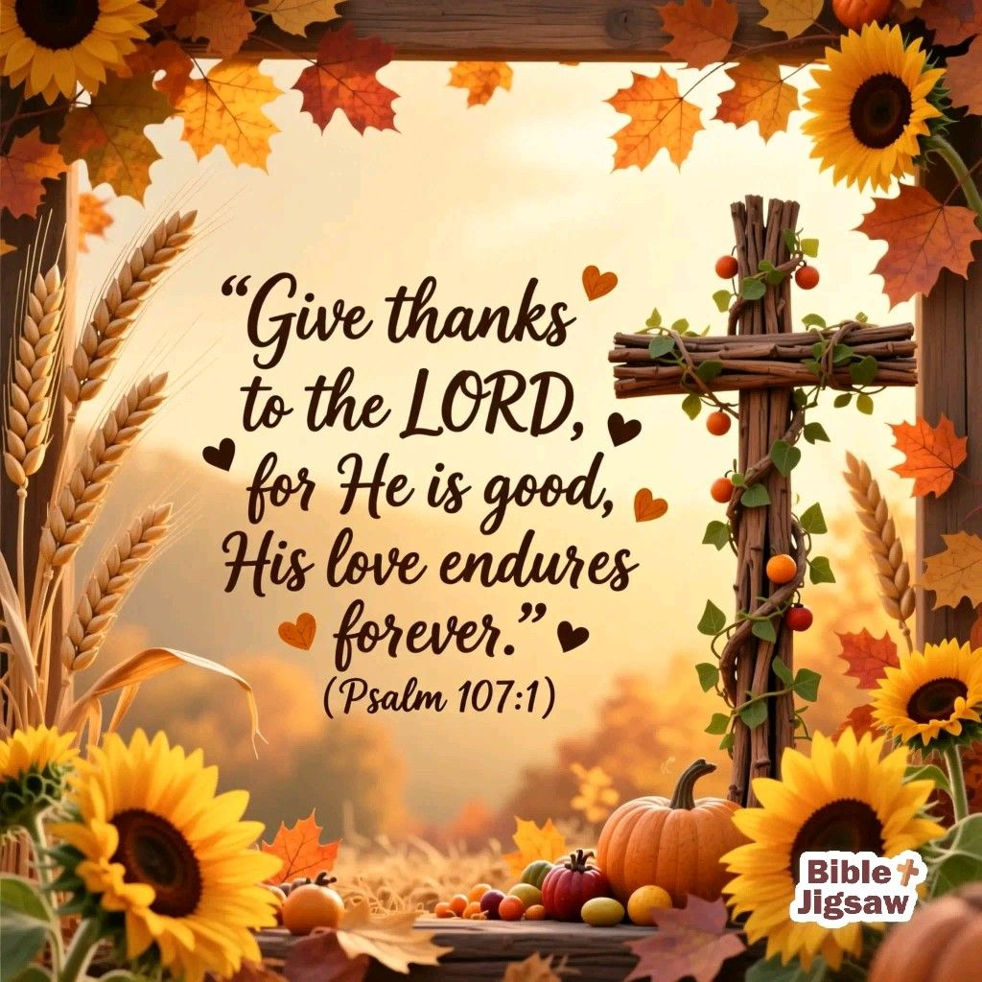
Minister: Rev. Susan Walters
Cell Phone: 716-983-5760
Church Office: 585-493-2840

Pastor Sue’s Office Hours
Tuesday & Thursdays
8:00 AM - 12:00 PM
Wed. 4:00 – 6:00 PM
Or by appointment

Church Office & Building Hours:
Tues. thru Fri. 8:00 AM- 2:00 PM

E-mail: Castile_UCC@yahoo.com

Director of Music &
Church Choir Director
Barbara Meyer
Handbell Choir Director
J. Thomas Reagan

Worship Technology Team
Jacob Klein James Loomis
Jeff Mattingly Steve Meyer
Charles Miller Tom Reagan
Barb Meyer

Lay Leader:
Michelle Post

Altar Flowers:
Brooke VanEpps

Attendance: 8/30/2026
43 in person 202 FB Views

Deposits for 8/30/2026 are:
Operational $1,985.00
Loose offering $70.00
Total deposit $2,055.00
Missions: $78.00

